HANOI UNIVERSITY OF SCIENCE AND TECHNOLOGY



**SCHOOL OF ELECTRICAL AND ELECTRONIC ENGINEERING**

BACHELOR GRADUATION THESIS

**Designing and building website to find rooms and roommates for students**

**Student:** Nguyen Ngoc Dung ET-E4 K64

**Student number:** 20193209

**Supervisor:** Ph.D. Nguyen Quang Minh

**Major:** Electronics and Telecommunication Engineering

HANOI UNIVERSITY OF SCIENCE AND TECHNOLOGY



**SCHOOL OF ELECTRICAL AND ELECTRONIC ENGINEERING**

BACHELOR GRADUATION THESIS

**Designing and building website to find rooms and roommates for students**

**Student:** Nguyen Ngoc Dung ET-E4 K64

**Student number:** 20193209

**Supervisor:** Ph.D. Nguyen Quang Minh

**Major:** Electronics and Telecommunication Engineering

**ĐÁNH GIÁ QUYỂN ĐỒ ÁN TỐT NGHIỆP**

(Dùng cho giảng viên hướng dẫn)

Tên giảng viên đánh giá: ..................................................................................................

Họ và tên Sinh viên: .......................................................MSSV:......................................

Tên đồ án: .........................................................................................................................

..........................................................................................................................................

### Chọn các mức điểm phù hợp cho sinh viên trình bày theo các tiêu chí dưới đây:

Rất kém (1); Kém (2); Đạt (3); Giỏi (4); Xuất sắc (5)

|  |  |  |  |  |  |  |
| --- | --- | --- | --- | --- | --- | --- |
| **Có sự kết hợp giữa lý thuyết và thực hành (20)** | | | | | | |
| 1 | Nêu rõ tính cấp thiết và quan trọng của đề tài, các vấn đề và các giả thuyết (bao gồm mục đích và tính phù hợp) cũng như phạm vi ứng dụng của đồ  án | 1 | 2 | 3 | 4 | 5 |
| 2 | Cập nhật kết quả nghiên cứu gần đây nhất (trong nước/quốc tế) | 1 | 2 | 3 | 4 | 5 |
| 3 | Nêu rõ và chi tiết phương pháp nghiên cứu/giải quyết vấn đề | 1 | 2 | 3 | 4 | 5 |
| 4 | Có kết quả mô phỏng/thưc nghiệm và trình bày rõ ràng kết quả đạt được | 1 | 2 | 3 | 4 | 5 |
| **Có khả năng phân tích và đánh giá kết quả (15)** | | | | | | |
| 5 | Kế hoạch làm việc rõ ràng bao gồm mục tiêu và phương pháp thực hiện  dựa trên kết quả nghiên cứu lý thuyết một cách có hệ thống | 1 | 2 | 3 | 4 | 5 |
| 6 | Kết quả được trình bày một cách logic và dễ hiểu, tất cả kết quả đều được phân tích và đánh giá thỏa đáng. | 1 | 2 | 3 | 4 | 5 |
| 7 | Trong phần kết luận, tác giả chỉ rõ sự khác biệt (nếu có) giữa kết quả đạt  được và mục tiêu ban đầu đề ra đồng thời cung cấp lập luận để đề xuất hướng giải quyết có thể thực hiện trong tương lai. | 1 | 2 | 3 | 4 | 5 |
| **Kỹ năng viết quyển đồ án (10)** | | | | | | |
| 8 | Đồ án trình bày đúng mẫu quy định với cấu trúc các chương logic và đẹp mắt (bảng biểu, hình ảnh rõ ràng, có tiêu đề, được đánh số thứ tự và được giải thích hay đề cập đến trong đồ án, có căn lề, dấu cách sau dấu chấm, dấu phẩy v.v), có mở đầu chương và kết luận chương, có liệt kê tài liệu  tham khảo và có trích dẫn đúng quy định | 1 | 2 | 3 | 4 | 5 |
| 9 | Kỹ năng viết xuất sắc (cấu trúc câu chuẩn, văn phong khoa học, lập luận  logic và có cơ sở, từ vựng sử dụng phù hợp v.v.) | 1 | 2 | 3 | 4 | 5 |
| **Thành tựu nghiên cứu khoa học (5) (chọn 1 trong 3 trường hợp)** | | | | | | |
| 10a | Có bài báo khoa học được đăng hoặc chấp nhận đăng/đạt giải SVNC khoa  học giải 3 cấp Viện trở lên/các giải thưởng khoa học (quốc tế/trong nước) từ giải 3 trở lên/ Có đăng ký bằng phát minh sáng chế | 5 | | | | |

|  |  |  |
| --- | --- | --- |
| 10b | Được báo cáo tại hội đồng cấp Viện trong hội nghị sinh viên nghiên cứu khoa học nhưng không đạt giải từ giải 3 trở lên/Đạt giải khuyến khích  trong các kỳ thi quốc gia và quốc tế khác về chuyên ngành như TI contest. | 2 |
| 10c | Không có thành tích về nghiên cứu khoa học | 0 |
| **Điểm tổng** | | **/50** |
| **Điểm tổng quy đổi về thang 10** | |  |

***Nhận xét khác*** *(về thái độ và tinh thần làm việc của sinh viên)*

..........................................................................................................................................

..........................................................................................................................................

..........................................................................................................................................

..........................................................................................................................................

..........................................................................................................................................

..........................................................................................................................................

Ngày: … / … / 20…

### Người nhận xét

(Ký và ghi rõ họ tên)

**ĐÁNH GIÁ QUYỂN ĐỒ ÁN TỐT NGHIỆP**

(Dùng cho cán bộ phản biện)

Giảng viên đánh giá:.........................................................................................................

Họ và tên sinh viên: ........................................................ MSSV:.....................................

Tên đồ án: .........................................................................................................................

..........................................................................................................................................

### Chọn các mức điểm phù hợp cho sinh viên trình bày theo các tiêu chí dưới đây:

Rất kém (1); Kém (2); Đạt (3); Giỏi (4); Xuất sắc (5)

|  |  |  |  |  |  |  |
| --- | --- | --- | --- | --- | --- | --- |
| **Có sự kết hợp giữa lý thuyết và thực hành (20)** | | | | | | |
| 1 | Nêu rõ tính cấp thiết và quan trọng của đề tài, các vấn đề và các giả thuyết  (bao gồm mục đích và tính phù hợp) cũng như phạm vi ứng dụng của đồ án | 1 | 2 | 3 | 4 | 5 |
| 2 | Cập nhật kết quả nghiên cứu gần đây nhất (trong nước/quốc tế) | 1 | 2 | 3 | 4 | 5 |
| 3 | Nêu rõ và chi tiết phương pháp nghiên cứu/giải quyết vấn đề | 1 | 2 | 3 | 4 | 5 |
| 4 | Có kết quả mô phỏng/thưc nghiệm và trình bày rõ ràng kết quả đạt được | 1 | 2 | 3 | 4 | 5 |
| **Có khả năng phân tích và đánh giá kết quả (15)** | | | | | | |
| 5 | Kế hoạch làm việc rõ ràng bao gồm mục tiêu và phương pháp thực hiện dựa trên kết quả nghiên cứu lý thuyết một cách có hệ thống | 1 | 2 | 3 | 4 | 5 |
| 6 | Kết quả được trình bày một cách logic và dễ hiểu, tất cả kết quả đều được phân tích và đánh giá thỏa đáng. | 1 | 2 | 3 | 4 | 5 |
| 7 | Trong phần kết luận, tác giả chỉ rõ sự khác biệt (nếu có) giữa kết quả đạt  được và mục tiêu ban đầu đề ra đồng thời cung cấp lập luận để đề xuất hướng giải quyết có thể thực hiện trong tương lai. | 1 | 2 | 3 | 4 | 5 |
| **Kỹ năng viết quyển đồ án (10)** | | | | | | |
| 8 | Đồ án trình bày đúng mẫu quy định với cấu trúc các chương logic và đẹp mắt (bảng biểu, hình ảnh rõ ràng, có tiêu đề, được đánh số thứ tự và được giải thích hay đề cập đến trong đồ án, có căn lề, dấu cách sau dấu chấm, dấu phẩy v.v), có mở đầu chương và kết luận chương, có liệt kê tài liệu  tham khảo và có trích dẫn đúng quy định | 1 | 2 | 3 | 4 | 5 |
| 9 | Kỹ năng viết xuất sắc (cấu trúc câu chuẩn, văn phong khoa học, lập luận  logic và có cơ sở, từ vựng sử dụng phù hợp v.v.) | 1 | 2 | 3 | 4 | 5 |
| **Thành tựu nghiên cứu khoa học (5) (chọn 1 trong 3 trường hợp)** | | | | | | |
| 10a | Có bài báo khoa học được đăng hoặc chấp nhận đăng/đạt giải SVNC khoa  học giải 3 cấp Viện trở lên/các giải thưởng khoa học (quốc tế/trong nước) từ giải 3 trở lên/ Có đăng ký bằng phát minh sáng chế | 5 | | | | |
| 10b | Được báo cáo tại hội đồng cấp Viện trong hội nghị sinh viên nghiên cứu khoa học nhưng không đạt giải từ giải 3 trở lên/Đạt giải khuyến khích trong các kỳ thi quốc gia và quốc tế khác về chuyên ngành như TI contest. | 2 | | | | |

|  |  |  |
| --- | --- | --- |
| 10c | Không có thành tích về nghiên cứu khoa học | 0 |
| **Điểm tổng** | | **/50** |
| **Điểm tổng quy đổi về thang 10** | |  |

#### Nhận xét khác của cán bộ phản biện

..........................................................................................................................................

..........................................................................................................................................

..........................................................................................................................................

..........................................................................................................................................

..........................................................................................................................................

Ngày: … / … / 20…

### Người nhận xét

(Ký và ghi rõ họ tên)

# PREFACE

In the current era of rapid technological advancement, the development of software and applications has significantly enhanced productivity and efficiency across various tasks. Information technology has been widely integrated into different socio-economic sectors, revolutionizing traditional processes. Among these, the education sector, particularly student accommodation, is ripe for innovation. The task of finding suitable hostels and compatible roommates is often a challenging and time-consuming endeavor for students. Recognizing this, the project aims to design and build a website that simplifies locating hostels and selecting roommates.

This website will serve as a comprehensive platform where students can search for available accommodation options and connect with potential roommates. By leveraging modern web technologies, the site will offer a user-friendly interface, real-time updates, and personalized recommendations, streamlining the search and selection process.

I would like to express my deepest gratitude to Ph.D. Nguyen Quang Minh, whose guidance and valuable insights have been instrumental throughout the development of this project. I am also thankful for the experiences gained during my academic journey, which have been pivotal in the execution of this thesis.

Due to the limited timeframe and the scope of knowledge required for such an undertaking, there may be imperfections in the project’s execution. I am open to and eagerly await constructive feedback that will refine my knowledge and enhance the quality of my future work.

In closing, I wish Ph.D. Nguyen Quang Minh continued health and success in their noble pursuit of education. Once again, I extend my heartfelt thanks.

# GUARANTEE

I am Nguyen Ngoc Dung, student code 20193209, a student of Electronics Program 01, course 64. The instructor is a Ph.D. Nguyen Quang Minh. I affirm that the “Design and Build a website to Find Hostels and Roommates for Students” project is a product of my own research and academic efforts. The data presented herein are authentic and accurately represent the findings of my work. All referenced materials adhere to intellectual property laws, with sources duly cited. I assume complete responsibility for the veracity of the information contained within this project.

HaNoi, 15/06/2024

**Student**

**Nguyen Ngoc Dung**

# CHAPTER I: INTRODUCTION

## 1.1 Problem.

Today, as society continues to develop, many workers and students are moving away from home to work or study, making it crucial to find accommodation near their workplace or school. Not every work area or school has enough dormitories for workers or students, especially during hot, rainy, or cold days, which causes inconvenience and difficulty in finding rental rooms, particularly for students and even for working individuals.

Information technology, and especially the Internet, has transformed the way people live, communicate, work, and access diverse and fast information sources. The advent of the Internet has become a powerful tool for those looking for resources in general or searching for rental rooms in particular, making it easier than ever. For those in need of renting accommodation, traditional search methods can be challenging, time-consuming, and labor-intensive to find rooms that meet their criteria. For landlords, reaching potential tenants is quite challenging due to location and limited communication methods. Now, with the advent of network systems, just a computer connected to the internet allows us to post and search for rental rooms anywhere, with prices suitable to our needs easily.

From these reasons, I decided to choose the topic "Building a website to Finding Rental Rooms." With the desire to create a website that supports users in posting and searching for rental rooms that match their needs.

## 1.2 Purpose and requirements.

### 1.2.1. Purpose.

Currently, there are many websites and applications on the internet that help users search for and post rental listings, such as phongtro123.com, nhatot.com, and ohanaliving.vn. While these websites generally meet the functional requirements of a rental search platform, they share a common issue: the cost of posting listings is too high. Landlords have to pay a significant fee to list their rentals on these websites.

Based on the user need for posting and searching for rental information, I propose a solution: building a website to support rental searches. This website will enable landlords to post their rental listings at a very low cost and allow those seeking rentals to search for rooms for free. The website will cater to the majority of users looking for rental accommodations today. Additionally, the website will provide functionalities for administrators to manage all system information, such as user accounts, rental listings, and revenue. It will also offer landlords features such as posting listings, managing rooms, and managing posts.

The rental search website will provide a large amount of information about houses and rooms available for rent. Visitors to the site can use search functions to find rentals by area, such as city or district, by specific address, by rental price, and by amenities offered.

Furthermore, the website will provide detailed information about the available rentals, including addresses, email contacts, and phone numbers, allowing users to contact landlords directly.

**1.2.1.1 Requirements**.

* Develop a simple, user-friendly interface that is easy to use.
* Research and understand the essential information needed for a rental listing.
* Gather requirements from real users to determine what information they need about a rental room.
* Clearly specify requirements.
* Design the system specification using an object-oriented approach for easy development.
* Implement the system using a RESTful API approach to facilitate easy upgrades and maintenance when issues arise.
* Build a complete website with all necessary features.

## 1.3 Research situations.

**1.3.1 Situation**

Renting accommodation has always been a perennial issue. Every year, hundreds of thousands of students from various provinces across the country come to study at universities, colleges, and vocational schools. Additionally, many employees working far from home also need to rent houses or rooms. However, the dormitory facilities at schools or companies can only meet the needs of less than 10% of the students and employees. The remaining students and employees have to face the challenge of finding rental accommodation near their study or work areas, which are often very expensive and do not meet the required quantity or quality of living conditions.

Hanoi is one of the cities with the highest density of universities in the country, attracting tens of thousands of students from all over to study. Although many universities have their own dormitories and the city has student housing, not all students qualify to live there. Additionally, some students, either because they have the financial means or because they want to live more comfortably and not be constrained by dormitory regulations, choose to seek off-campus housing.

With the significant increase in the number of students, the demand for rental accommodation in Hanoi is rising, making the student rental market extremely dynamic and competitive. This has led to a shortage of available rentals and fierce price competition among landlords. As a new academic year approaches, rental prices in areas near top universities are significantly higher compared to other areas.

One of the main challenges for students in finding rental accommodation is the quality and amenities of the rooms. Due to high demand, many rental properties fail to meet the standards for security, hygiene, fire safety, and basic amenities. Students often have to compromise between affordable rent and quality of living conditions.

In January 2024, Vietnam had a total of 78.44 million Internet users, with an Internet penetration rate of 79.1% of the total population. Analysis by Kepios indicates that the number of Internet users in Vietnam increased by an additional 502 thousand (+0.6%) from January 2023 to January 2024. This growth underscores the increasing number of Internet users, leading to a higher demand for accessing rental accommodation information. Therefore, using websites to search for rental accommodations has completely replaced traditional methods, which is entirely reasonable and aligned with current trends.

Some websites support finding accommodations in Vietnam:

* Website phongtro123.com

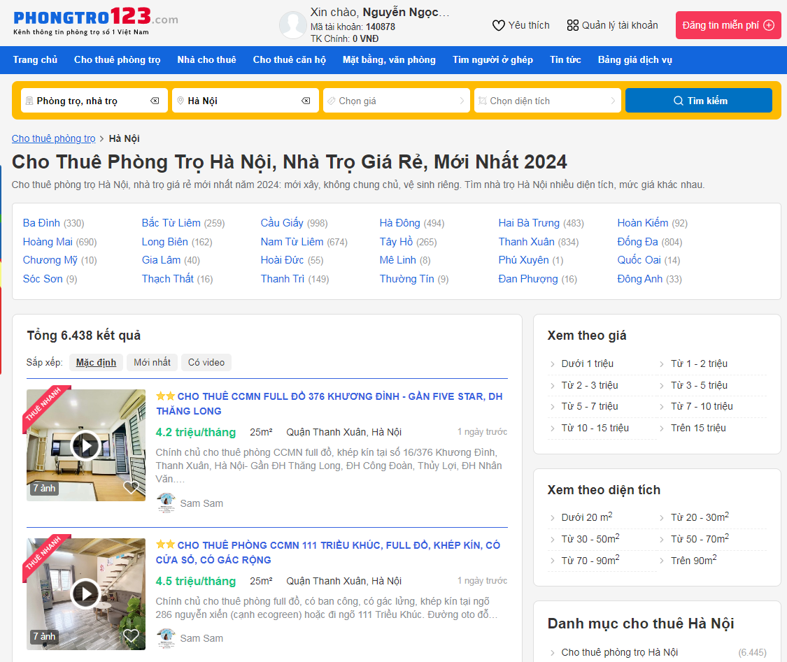

Image 1: Website phongtro123.com

* Website nhatot.com

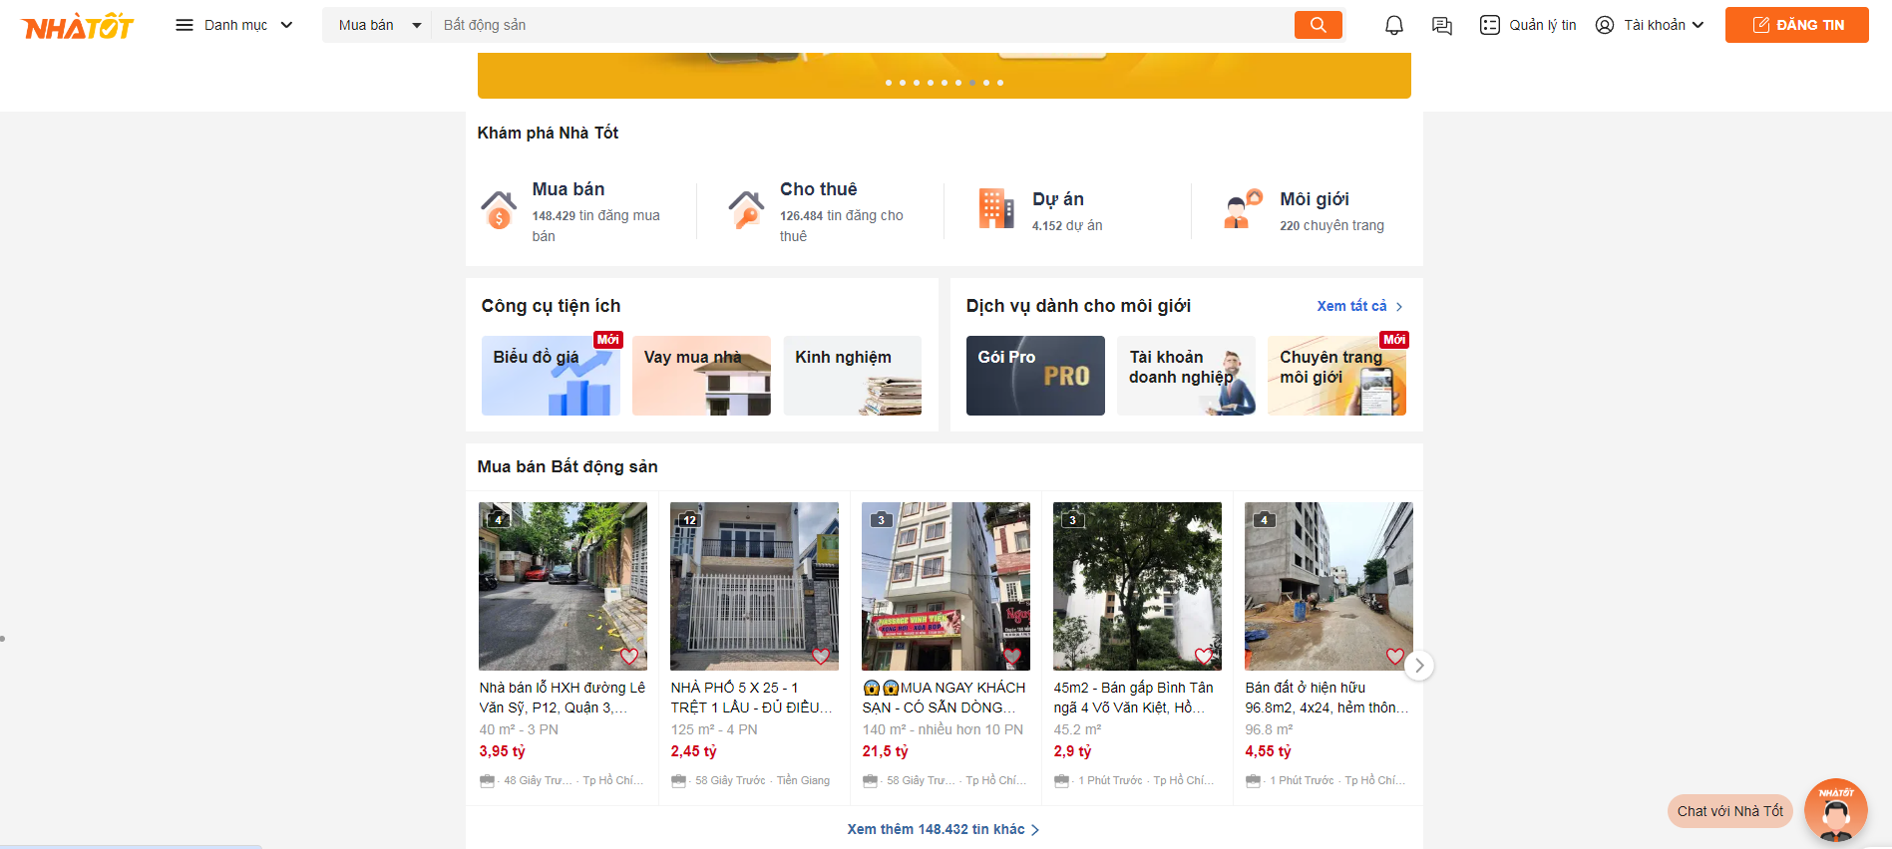

Image 2: Website nhatot.com

* Website ohanaliving.vn

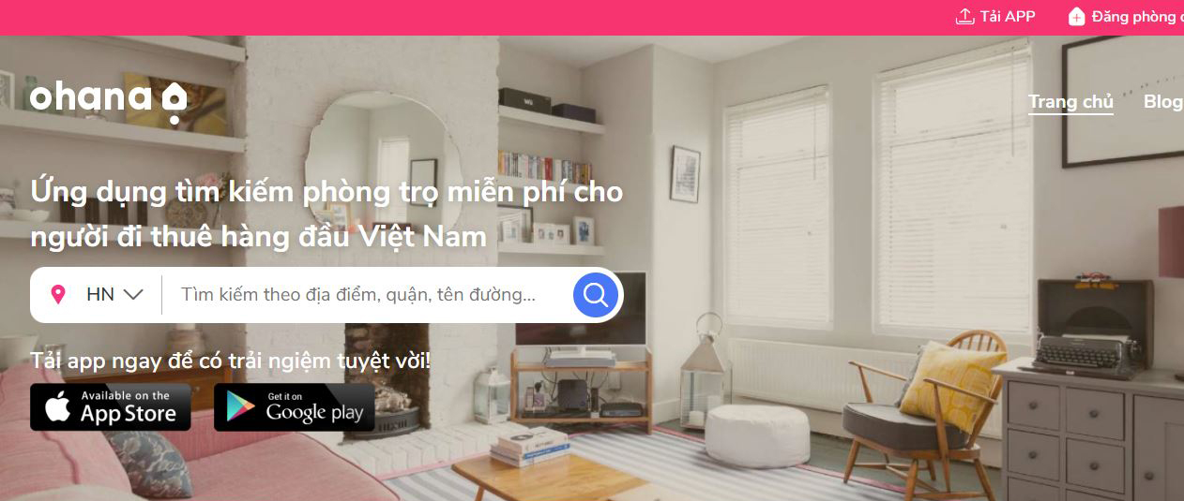

Image 3: Website ohanaliving.vn

* + 1. **The importance of this topic.**

The demand for accommodation for students and workers has been a persistent and challenging issue for many years, especially with the increasing number of students and workers studying or working far from home nowadays. Finding satisfactory rental accommodations is difficult due to the rise of fraudulent listings. Scammers take advantage of renters' vulnerabilities to deceive them into paying deposits or inflate rental prices through intermediaries who sublet at exorbitant rates, making it financially burdensome for many to secure housing.

Providing solutions to the housing issue for workers and students not only improves quality of life but also contributes to the overall socio-economic development of the country.

The "Accommodation Search Support" website is created to directly connect renters and landlords without intermediaries, offering affordable fees for listings. It provides accurate and quick information for renters to find accommodation within desired price ranges and locations. This platform helps renters find housing without the need for extensive travel to search for rental properties.

Therefore, this topic is not only highly relevant but also holds significant importance for the community, contributing to improving living conditions and reducing difficulties in finding accommodations for students and workers in Vietnam.

**CHAPTER 2: THEORETICAL BACKGROUND**

**2.1 Front end.**

2.1.1 HTML

HTML stands for Hypertext Markup Language, which is the most widely used language for writing web pages.

HTML is a markup language. This means using HTML to mark up a text document with tags to instruct the web browser on how to structure it for display on the screen.

HTML can be thought of as helping us create the "skeleton" of a website.

Advantages of HTML:

* It has abundant support resources within a vast user community
* It can smoothly operate on almost all modern web browsers.
* HTML markup tags are typically concise and highly consistent.
* It is open-source and completely free.
* HTML is a web standard governed by the W3C.
* It is easy to integrate with various backend languages (e.g., PHP, Node.js, Java,...).

2.1.2 CSS

CSS stands for Cascading Style Sheets, a language used to format elements created by markup languages like HTML. In other words, while HTML structures elements on a website such as headings, tables, and paragraphs, CSS enriches and enhances these HTML elements by styling them, changing text colors, adding background colors, or modifying page layouts.

It can be understood that HTML creates the "skeleton" of a website, while CSS provides the colors, cosmetics, and appearance.

2.1.3 JavaScript

JavaScript is a widely used programming language for websites today, integrated and embedded into HTML to make websites more dynamic. JavaScript acts as part of a webpage, executing client-side scripts that enable both user-side and server-side (Node.js) functionalities to create dynamic web pages.

JavaScript is an interpreted programming language with object-oriented capabilities. It is one of the three main languages in web development and has interdependencies to build professional, dynamic websites.

The role of JavaScript is to manipulate HTML objects within the browser. It can easily intervene in actions such as adding, deleting, or modifying CSS properties and HTML tags. In other words, JavaScript is a client-side programming language for browsers.

JavaScript can fetch data from the server through APIs returned as JSON strings and display them on the user interface. It can also retrieve data entered into forms on the interface and call APIs to save the data to the server.

**2.2 Backend**

2.2.1 Java

Java is one of the object-oriented programming languages used in software development, web applications, games, and mobile applications. It was initiated by James Gosling and colleagues at Sun Microsystems in 1991, originally named Oak with the purpose of programming consumer electronic devices.

Unlike some other languages that run only in specific environments, Java programs can run effectively in various environments, known as "cross-platform" capability. This hardware and operating system independence is demonstrated at both the source code and binary levels.

Java is a powerful and versatile programming language capable of developing websites, apps, AI, embedded systems, and more.

Java boasts several outstanding advantages:

* It enforces strict data type requirements.
* Java tightly controls access to arrays and strings, preventing buffer overflow techniques. Thus, accesses do not exceed the size of arrays or strings.
* Memory allocation and deallocation processes are handled automatically.
* Error handling mechanisms simplify error recovery and management.

However, Java also has some limitations compared to other languages:

* Like other interpreted languages, executing Java code is slower than compiled languages (though within acceptable limits).

2.2.2 Spring framework

Spring is a Java framework widely used by millions of developers for developing high-performance, easily testable, and reusable code applications.

Spring is an open-source framework developed, shared, and supported by a large community of users. It is built upon two core design principles: Dependency Injection and Aspect-Oriented Programming. The core features of Spring can be used to develop Java Desktop, mobile applications, and Java Web applications. Spring's primary goal is to simplify the development of J2EE applications based on the POJO (Plain Old Java Object) model.

Spring is divided into several modules, each serving different application development purposes.

Benefits of the Spring framework include:

* Spring allows developers to use POJOs, simplifying work without needing to deal with EJB, application threading, configuration, etc.
* Spring is modularly organized. Although it consists of many packages and classes, developers only need to focus on what they need, ignoring the rest.
* Spring supports various technologies such as ORM Framework, logging frameworks, JEE, scheduling libraries (Quartz and JDK timer), etc.
* The Spring Web module is designed based on the MVC pattern, providing comprehensive features that replace other web frameworks like Struts.

Spring provides projects like Spring Security, which enhances authentication and authorization mechanisms for projects, ensuring secure user authentication and access control.

Spring Boot: This framework facilitates rapid development and deployment of web applications.

2.2.3 Hibernate

Hibernate is an open-source Object Relational Mapping (ORM) library that helps Java developers write applications by mapping objects (POJOs) to relational database management systems, supporting object-oriented programming concepts with relational databases.

With Hibernate, developers do not need to work directly with the database as they would with JDBC. Instead, they work with databases through classes that represent tables in the database. Before Hibernate, developers had to use JDBC to write lengthy and verbose SQL queries, which often resulted in poor performance due to frequent opening and closing of connections. With Hibernate, developers no longer need to write verbose SQL queries or manage connections manually multiple times.

**2.3 Database management system (DBSM)**

Database management system:

* It is a system designed to automatically and systematically manage a specific volume of data. Management actions include editing, deleting, storing, and searching (retrieving information) within a defined dataset.
* It is a software package designed to define, manipulate, retrieve, and manage data within a database.

Roles of a Database Management System:

* Provides an environment for creating databases: DBMS plays a role in providing users with a data definition language to describe, declare data types, and data structures.
* Provides methods for updating and exploiting data: DBMS provides users with a data manipulation language to express requests, update operations, and data exploitation. Data operations include Updating (inserting, editing, deleting data), Exploitation (searching, extracting data).
* Provides tools to control and manage access to the database to ensure the implementation of basic database requirements.

Thanks to its useful functions and high performance, many DBMSs have been developed with the aim of improving data processing capabilities for computer software, websites, etc.

* Popular Database Management Systems today include MySQL, Oracle, SQLite, MongoDB, PostgreSQL... For this problem, I choose to use MySQL as the database management system.

MySQL:

* One of the most popular databases for web applications.
* This DBMS tool allows the selection of multiple storage engines.
* User-friendly interface and batch commands.

Advantages:

* MySQL is free.
* Provides extensive functionality.
* Various user interfaces, including web and desktop app versions.
* It can operate on other databases like DB2 and Oracle.

Disadvantages:

* Requires more time to work with MySQL compared to automated systems.
* Does not support XML or OLAP integration.
* Support is available in the free version but requires payment for certain features.

**2.4 Tools used.**

2.4.1 IntelliJ IDE.



Image 4: Tool IntelliJ IDE

IntelliJ IDEA is an IDE used for Java programming (it also supports programming in some other languages like Node.js, Python...).

Generally, IntelliJ IDEA is similar to Eclipse because it is primarily used for Java but can also support other languages and has numerous supporting plugins.

IntelliJ IDEA has two editions: a free version (Community) and a paid version (Ultimate). The paid version includes additional support for JavaScript, TypeScript, and plugins like GWT, Vaadin, and duplicate code detection.

2.4.2 MySQL Workbench.



Image 5: Tool MySQL Workbench

MySQL Workbench is a visual database design tool and integrated development environment (IDE) for MySQL. It provides a graphical interface to design, model, and manage MySQL databases.

Similar to IntelliJ IDEA for Java development, MySQL Workbench is tailored specifically for MySQL databases but offers broader functionality. It supports tasks such as database modeling, SQL development, and administration through a user-friendly graphical interface.

MySQL Workbench is available in two editions: Community (free) and Standard/Enterprise (paid), with the latter offering advanced features like database migration, performance monitoring, and collaboration tools.

2.4.3 Postman



Image 6: Tool postman.

Postman is currently one of the most popular tools used for API testing. With Postman, you can call Rest APIs without writing any code.

Postman supports all HTTP methods (GET, POST, PUT, PATCH, DELETE, etc.). Additionally, it allows you to save the history of requests, which is very convenient for reuse when needed.

Benefits of using Postman:

* Using Collections: Postman allows users to create collections for their API calls. Each collection can have subfolders and multiple requests, which helps organize test sets.
* Collaboration: Collections and environments can be imported or exported, making it easy to share files.
* API Testing: Test the HTTP response status.
* Debugging: The Postman console helps check what data has been retrieved, making it easy to debug tests.

2.4.4 Visual Paradigm.

Visual Paradigm is a versatile software tool designed for modeling, designing, and managing software projects. It supports various modeling languages and methodologies, making it suitable for a wide range of applications.

Key features of Visual Paradigm include:

* UML Modeling: Comprehensive support for Unified Modeling Language (UML) diagrams.
* Business Process Modeling: Tools for Business Process Model and Notation (BPMN).
* Database Design: Visual tools for designing databases and generating SQL scripts.
* Agile and Scrum Support: Features for managing agile development and Scrum projects.
* Code Engineering: Code generation and reverse engineering for multiple programming languages.
* Collaboration: Team collaboration features, including version control and project sharing.
* Project Management: Tools for managing tasks, schedules, and resources within projects

2.5 Template Engine Thyme leaf.

Thymeleaf is a Java XML/XHTML/HTML5 Template Engine that can work in both web and non-web environments. It is more suitable for serving XHTML/HTML5 at the View Layer of web applications based on the MVC architecture. It can process any XML file, even in offline environments. It fully supports interaction with the Spring Framework.

Thymeleaf can be used as a replacement for JSP at the View Layer of an MVC web application. Thymeleaf is open-source software licensed under the Apache 2.0 license.

Thymeleaf code structure uses pure HTML code and does not employ any non-HTML tags, making it very user-friendly.

Typically, with views used in Java such as JSP or JSF, to see changes in the interface, you have to refresh the web page. However, with Thymeleaf, you can see changes in the interface without reloading the page, although by default, Thymeleaf cannot handle this issue directly.

2.6 Restful API

2.6.1 Define.

API is an intermediary method and protocol for connecting to other libraries and applications. It stands for Application Programming Interface. An API is not a programming language; it is simply a set of functions or procedures. These functions can be written in various programming languages. APIs provide access to a set of commonly used functions, enabling data exchange between applications.

APIs serve as a bridge between different applications and websites. Data from a website can be used by software and vice versa.

2.6.2 API Works

- First, build the API URL so that third parties can send data requests to the content-providing server via the HTTP or HTTPS protocol.

- On the content-providing web server, the source applications will perform authentication checks if any, and locate the appropriate resources to create the content for the response.

- The server returns the result in JSON or XML format via the HTTP/HTTPS protocol.

- At the initial request location, which could be a web or mobile application, the JSON/XML data will be parsed to extract the data. After obtaining the data, further actions such as saving it to a database or displaying it are performed.

- REST primarily operates based on the HTTP protocol. The basic activities mentioned above use specific HTTP methods.

- There are four main methods when working with REST APIs: GET, POST, PUT, DELETE, corresponding respectively to the functions: read, create, update, delete.

# CHAPTER 3 HIGH-LEVEL REQUIREMENTS

3.1 Introduction problems.

3.1.1 Problem statement

This is a website containing a large amount of information about houses and rooms that the owners do not currently need and want to rent out. Visitors to the website can use search functions based on location, such as by city, district, or by specific address, like the house number on a particular street. They can also search by rental price and the amenities of the houses or rooms available for rent. The website provides detailed information about the houses or rooms available for rent, including the address and contact phone number for the landlord.

Instead of visiting each place to see rental properties, users only need an internet-connected device to access the website and search for the rental information they need, then contact the landlord. The website also offers a real-time chat feature for users to conveniently exchange information.

3.1.2 Purpose of this system.

- **User Interface**: Design an intuitive interface that is easy to navigate and visually appealing.

- **Basic Functionality**: Implement essential features such as search functionality for finding rental information and an upload feature for landlords to post room details.

- **Optimized Performance**: Ensure the website is highly responsive by optimizing response times and loading speeds.

- **Cost Efficiency**: Minimize costs and distances for both landlords and tenants by efficiently connecting them through the platform.

- **Admin Management**: Provide an easy-to-use admin interface for managing room information and user interactions.

- **Accurate Data Management**: Ensure precise storage and retrieval of data to provide reliable information to users.

3.2 Requirements Specification.

3.2.1 Software Requirements Specification.

This document specifies the detailed requirements for a room rental web application, catering to administrators and customers. The application aims to facilitate efficient room management and rental transactions.

User Roles and Descriptions:

|  |  |
| --- | --- |
| Roles | Descriptions |
| Admin | Room and Pricing Management: Add, edit, and delete room types and pricing tiers.  User Management: Manage user accounts, including CRUD operations  Confirmation of Uploaded Rooms: Review and approve rooms uploaded by landlords.  Statistical Analysis: Generate reports on revenue, number of rooms in each region. |
| Customers | Search Functionality: Search for rooms based on room type, price range, area, etc.  Registration and Login: Create an account and securely log in.  Account Funding via Momo: Deposit funds into the account via Momo wallet to post more room listings. |

3.2.2 Functional Requirements Specification.

3.2.2.1 Main Features of the Website.

Storage of Room Rental Information:

* Store details about houses and rooms available for rent, such as location, address, rental price, and contact information for landlords.
* Ensure structured data storage for efficient and quick search functionality.

Attractive and User-Friendly Interface:

* Design an appealing and user-friendly interface accessible to all user types.

Flexible Search Functionality:

* Implement versatile search capabilities allowing users to quickly find rental information based on location, price range, and other relevant criteria.

3.2.2.2 Users.

**User Registration and Authentication**:

* Users can register for an account on the website. Upon successful registration, a confirmation code will be sent to the registered email address for verification.
* After successful verification, users can log in to the system using their credentials.

**Flexible Room Search**:

* Users can search for rental properties based on various criteria such as price, location (address or region), room type, and area size.

**Room Upload and Fee**:

* Users with authenticated accounts can upload room rental information. Each room upload will incur a fee of 10000 VND per submission.

**Management of Uploaded Room Information**:

* Logged-in users can manage the details of rooms they have uploaded, including editing or deleting listings as needed.

3.2.2.3 Admin.

**User Management**:

* Admin can manage user accounts, including viewing user details and account statuses.
* Admin has the authority to suspend or deactivate user accounts if suspicious activities are detected.

**Room Category Management:**

* Admin can add, edit, or delete room categories (types of rooms available for rent).

**Post Management:**

* Admin can add, edit, or delete room listings posted by users.

Statistical Analysis:

* Admin has access to statistical reports like revenue analysis and regional room count.

3.2.3 Non-functional requirements specifications.

3.2.3.1 Security.

- Data validation: All input forms must undergo thorough validation to prevent incorrect or incomplete data storage, ensuring data integrity and reliability.

- User Access Control: Users who are not logged in should not have access to account details or room information associated with accounts.

- Data Encryption and Security: User account information, including passwords, must be encrypted and securely stored. Admins should not have access to view user passwords.

- Registration and Password Recovery Authentication: Registration and password recovery processes must include email verification using a code sent to the user's registered email address.

- Admin Access Control: Access to the admin dashboard and functionalities should be restricted to admin accounts only, ensuring proper authorization mechanisms are in place.

- API Security: All APIs must be authenticated using access tokens to prevent unauthorized access and ensure secure communication between client and server.

- User Revocation: User privileges should be revoked upon logout to ensure ongoing security and access control.

3.2.3.2 Usability.

- Simple and User-Friendly Interface: The interface should be straightforward and easy to use for all user demographics, ensuring a positive user experience.

- Scalability Under Load: The system should handle multiple users accessing it concurrently without significant performance degradation, ensuring robust performance during peak times.

- Fast Response Times: The system should respond quickly to user requests, minimizing wait times and providing a responsive user experience.

- Data Encryption and Theft Prevention: Critical data, especially user-sensitive information, must be encrypted to prevent theft and unauthorized access.

- Frontend and Backend Input Validation: Validate user inputs both at the frontend (client-side) and backend (server-side) to ensure data integrity and prevent malicious input.

- Separation of Admin and User Interfaces: Admin and user interfaces should be distinctly separated, with appropriate access controls and functionalities restricted to their respective roles.

3.3 Entities relationships

3.3.1 Entities.

3.3.1.1 Define all entities.

|  |  |  |
| --- | --- | --- |
| No. | Entity | Role |
| 1 | Authority | Describe the main roles of this website |
| 2 | Blog | Describe the rental house post. |
| 3 | Category | Categorize the objectives of each room on the website. |
| 4 | User | Save and describe information of each user register account. |
| 5 | Contact | Describe the information to contact to users. |
| 6 | Room | Describe all information of each hostel. |
| 7 | Status room | Informing the owner about the validity of the room information. |
| 8 | Image room | Show images of this hostel to user can look at carefully. |
| 9 | Province | Save all provinces in Vietnam. |
| 10 | Districts | Save all districts of each province. |
| 11 | Wards | Save all wards of each district. |
| 12 | History pay | Save user payment information. |
| 13 | User-authority | Save role of each user. |

3.3.1.2 Data of each entity.

- Table authority

|  |  |  |  |
| --- | --- | --- | --- |
| No. | Field | Data type | Description |
| 1 | Name | Varchar(255) | Name of each authority |

- Table Category

|  |  |  |  |
| --- | --- | --- | --- |
| No. | Field | Data type | Description |
| 1 | ID | Bigint(20) | Primary key |
| 2 | Name | Varchar(255) | Name of each category |

- Table User

|  |  |  |  |
| --- | --- | --- | --- |
| No. | Field | Data type | Description |
| 1 | ID | Bigint(20) | Primary key |
| 2 | Activation-key | Varchar(255) | Status |
| 3 | Actived | Boolean | Lock status |
| 4 | Password | Varchar(255) | Password to login |
| 5 | Username | Varchar(255) | Email to login |
| 6 | Full name | Varchar(255) | Name of users |
| 7 | Phone | Varchar(255) | Information to contact |
| 8 | Created-date | Date | The day created account |
| 9 | Created time | Time | The hours created account |
| 10 | Amount | Double | Money of accounts to post hostels |
| 11 | Link-face | Varchar(255) | Information to contact via FB |
| 12 | Avatar | Varchar(255) | Present Image of each user |

- Table User-authority

|  |  |  |  |
| --- | --- | --- | --- |
| No. | Field | Data type | Description |
| 1 | User-ID | Bigint(20) | Sub key to link with table user |
| 2 | Authority name | Varchar(255) | Sub-key to link with table category |

- Table blog

|  |  |  |  |
| --- | --- | --- | --- |
| No. | Field | Data type | Description |
| 1 | ID | Bigint | Primary key |
| 2 | Content | Longtext | Content of this blog |
| 3 | Created-Date | Date | The date created this blog |
| 4 | Created-Time | Time | The time created this blog |
| 5 | Description | Longtext | Describe this blog |
| 6 | Image banner | Varchar(255) | Avatar |
| 7 | Title | Varchar(255) |  |
| 8 | User_ID | Bigint | Sub key to link with user who posts this blog |
| 9 | Vi_pham | Boolean | Status of blog |

- Table Province:

|  |  |  |  |
| --- | --- | --- | --- |
| No. | Field | Data type | Description |
| 1 | ID | Bigint | Primary key |
| 2 | Name | Varchar(20) | Name of all province in Vietnam |

- Table Districts:

|  |  |  |  |
| --- | --- | --- | --- |
| No. | Field | Data type | Description |
| 1 | ID | Bigint | Primary key |
| 2 | Name | Varchar(20) | Name of all Districts in Vietnam |
| 3 | Province_ID | Bigint | Sub-key to link with table province |

- Table Wards:

|  |  |  |  |
| --- | --- | --- | --- |
| No. | Field | Data type | Description |
| 1 | ID | Bigint | Primary key |
| 2 | Name | Varchar(20) | Name of all wards in Vietnam |
| 3 | Districts_ID | Bigint | Sub-key to link with table districts |

- Table Room:

|  |  |  |  |
| --- | --- | --- | --- |
| No. | Field | Data type | Desciption |
| 1 | ID | Bigint | Primary key |
| 2 | Area | Float | Size of this room |
| 3 | Banner | Varchar(255) | Avatar of this room |
| 4 | Created-date | Date | The date to post this room |
| 5 | Created-time | Time | The time to post this room |
| 6 | Description | Longtext | All important information of this room |
| 7 | Price | Double | The cost customer must pay a month |
| 8 | Street | Varchar | Exactly location |
| 9 | Title room | Varchar | Title of this room to rent |
| 10 | category_id | bigint | Sub-key to link with table category |
| 11 | user_id | bigint | Sub-key to link with table user |
| 12 | ward_id | bigint | Sub-key to link with table ward |
| 13 | status_room | bigint | Sub-key to link with status_room |

- Table Image Room :

|  |  |  |  |  |  |  |  |
| --- | --- | --- | --- | --- | --- | --- | --- |
| No. | Field | Data type | Description |  |  |  |  |
| 1 | ID | Bigint(20) | Primary key |  |  |  |  |
| 2 | link_image | varchar(255) | Link image to show this room |  |  |  |  |
| 3 | room_id | Bigint | Sub-key to link with table room |  |  |  |  |

- Table Status Room:

|  |  |  |  |  |  |  |  |
| --- | --- | --- | --- | --- | --- | --- | --- |
| STT | Field | Data type | Description |  |  |  |  |
| 1 | Id | Bigint(20) | Primary key |  |  |  |  |
| 2 | Name | Varchar(255) | Status of this room |  |  |  |  |

- Table History-pay:

|  |  |  |  |
| --- | --- | --- | --- |
| No. | Field | Data Type | Description |
| 1 | ID | Bigint | Primary key |
| 2 | Created Date | Date | The date transaction |
| 3 | Created Time | Time | The time transaction |
| 4 | Order-ID | Varchar | ID order online payment |
| 5 | Request-ID | Varchar | ID request online payment |
| 6 | Total amount | Double | Total money payment |

- Table contact:

|  |  |  |  |
| --- | --- | --- | --- |
| No. | Field | Data Type | Description |
| 1 | ID | Bigint | Primary key |
| 2 | Content | Varchar(255) | Content of this contact |
| 3 | Created_date | date | The date created contact |
| 4 | Created_time | time | The time created contact |
| 5 | da_xem | int | Status if admin see contact or not |
| 6 | Email | varchar(255) | Information show this user created contact |
| 7 | Fullname | varchar(255) | Name of user creating contact |

3.3.2 Relationship

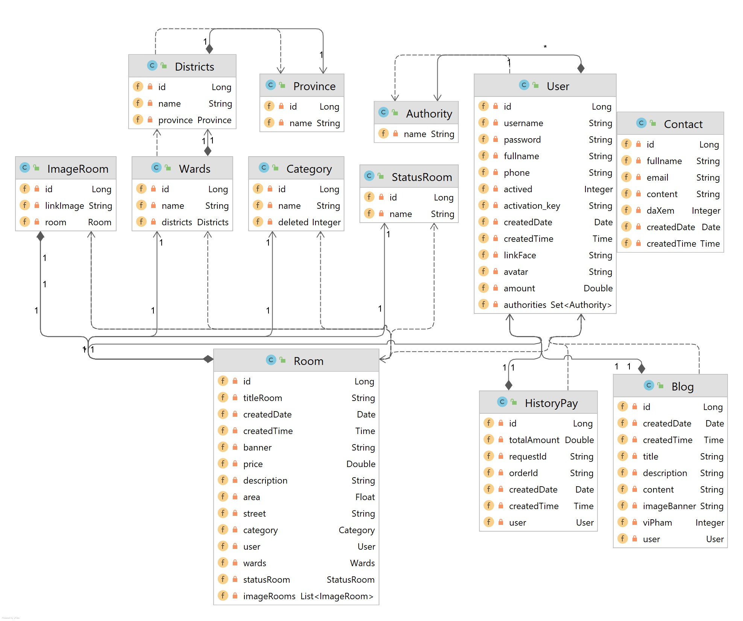

3.4 Use cases diagram

The use case diagram illustrates specific goals and how users interact with the system. The ellipses within the system boundary represent the system's use cases or functions, while the stick figures symbolize the actors or users of the system. The lines connecting the actors to the use cases indicate that the actors can perform those functions within the system to achieve their objectives.

3.4.1 Use case general.

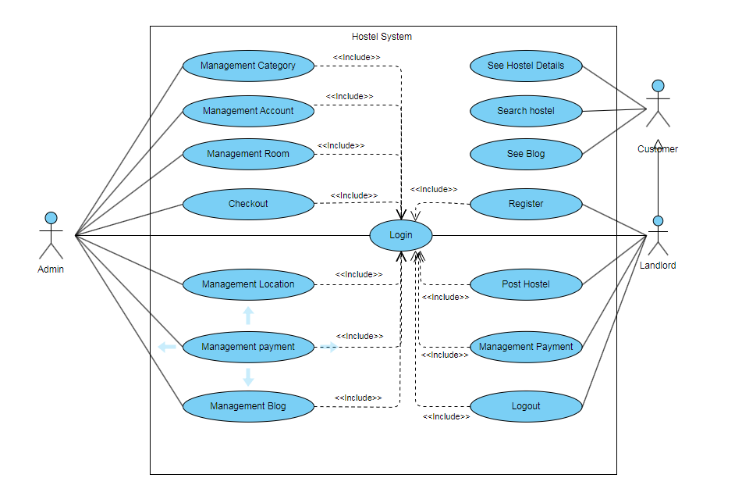

The website system comprises three main agents:

* Renter (or Tenant):

Description: A user who directly interacts with the website's features such as viewing posts, searching for rental rooms, and accessing detailed room information.

Functions: View posts, search for rooms, view room details.

* Landlord:

Description: The user who posts room listings, with functions including managing posts, creating listings, depositing funds, logging in, and registering.

Functions: Manage posts, create listings, deposit funds, log in, register.

* Administrator:

Description: The role responsible for overseeing the entire system, including user management, post management, room category management, article management, and revenue management.

Functions: Manage users, manage posts, manage room categories, manage articles, manage revenue.

3.4.2 Use case specifications

1, Use case view home page.

|  |  |
| --- | --- |
| Objective | This use case allows all people to see the home page. |
| Actor | Website visitors (Guest, User, Admin) |
| Pre-condition | The visitor must have internet access and a compatible web browser. |
| Main flow | 1: The visitor navigates to the website’s URL. 2: The system verifies if the visitor has an active session. 3: The system accesses the database to gather the required display information.  4: The system presents the homepage to the visitor. |
| Post condition | The visitor is able to view the homepage and interact with its content. |

* Activities flow:

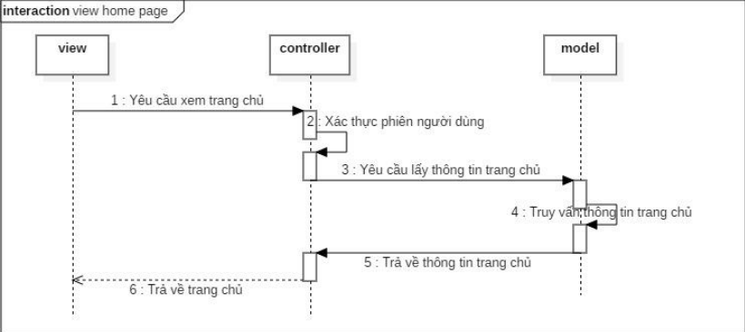

2, Use case registration

|  |  |
| --- | --- |
| Objective | This use case defines the process and requirements for user registration on the online room rental website. |
| Actor | New users seeking to register. |
| Pre-condition | The user must have access to the internet and the website. |
| Main flow | 1: The user selects the ‘Register’ option on the website. 2: The user fills in the required information in the registration form. 3: The user submits the form.  4: If the information is valid, the system creates a new user account.  5: The system sends a confirmation email to the user. |
| Post-condition | The user has successfully created an account and can now log in to use the website’s services. |

* Activities flow:

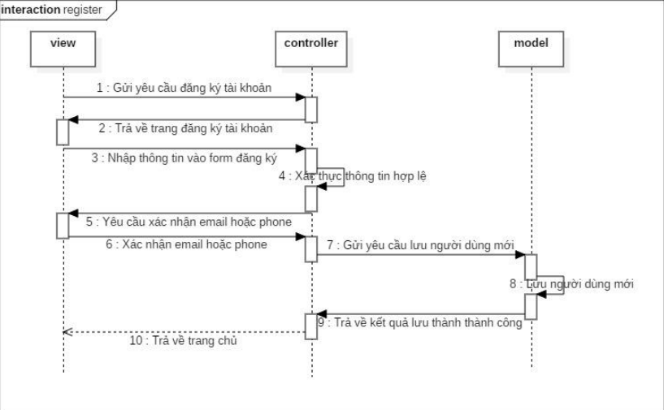

3, Use case search hostel

|  |  |
| --- | --- |
| Objective | This use case searches for hostels based on users’ requirements on the website. |
| Actor | Potential guests looking for accommodation. (Guest, User, Admin) |
| Pre-condition | The user must have internet access and be on the hostel search |
| Main flow | 1: The user enters search criteria such as location, dates, area, and price.  2: The system processes the search query.  3: The system retrieves hostel information that matches the criteria from the database.  4: The system displays a list of hostels that meet the user’s requirements.  5: The system displays a list of hostels that meet the user’s requirements. |
| Post condition | The user is presented with a list of hostels and can proceed to view more details or make a reservation. |

* Activities flow:

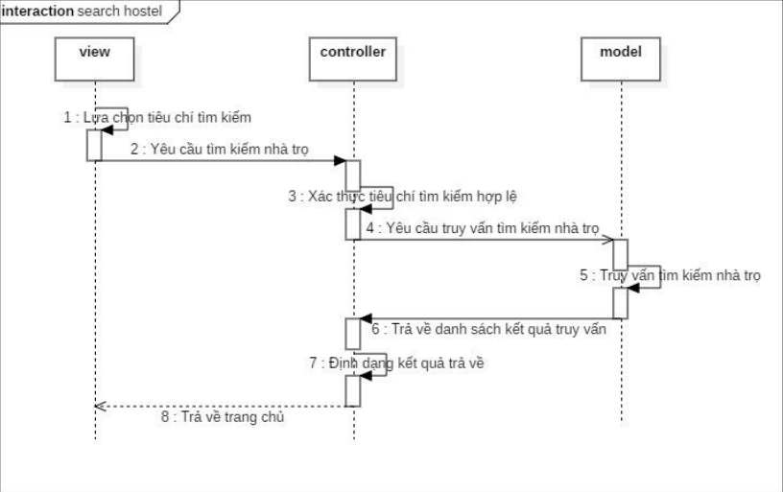

4, Use case View hostel detail.

|  |  |
| --- | --- |
| Objective | This use case allows all website’s visitors view detailed information about a specific hostel on the website. |
| Actor | Potential guests interested in hostel accommodations. |
| Pre-condition | The user must have internet access and be on the website. |
| Main flow | 1: The user selects a hostel from all hostels or the search results  2: The system retrieves detailed information about the selected hostel from the database. 3: The system displays the detailed information, including photos, amenities, and pricing. |
| Post condition | The user has access to comprehensive information about the hostel, which aids in making an informed decision. |

* Activities flow:

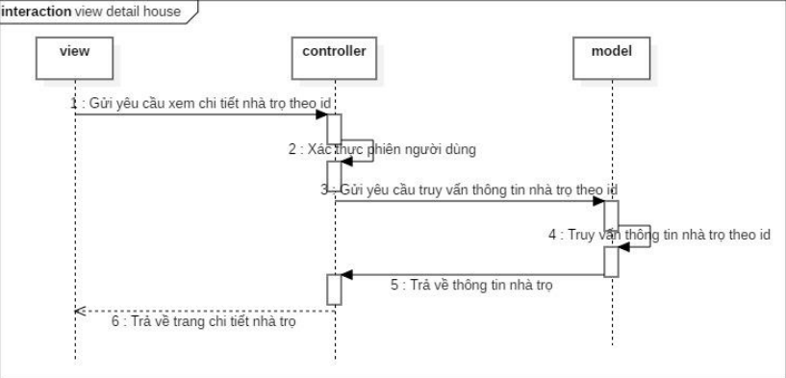

5, Use case Login

|  |  |
| --- | --- |
| Objective | This use case allows users to login to the website |
| Actor | Users |
| Pre-condition | The user must be registered and have valid login credentials. |
| Main flow | 1: The user navigates to the login page. 2: The user enters their username and password.  3: The system verifies the credentials.  3.1: If the credentials are wrong, the system will notice errors and return to login page.  3.2: If the credentials are correct, the system grants access to the user’s account.  4: The user is redirected to the homepage or their dashboard. |
| Post condition | The user is logged in and can access features available to registered users. |

* Activities flow:

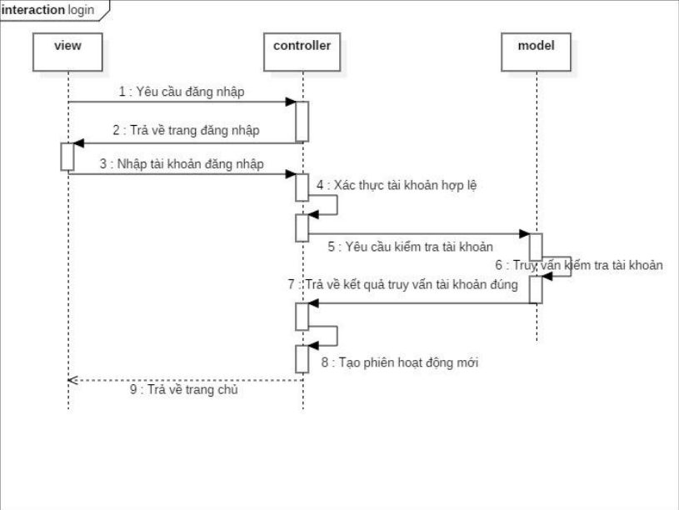

6, Use case Restore password

|  |  |
| --- | --- |
| Objective | This use case allows users to restore or reset their password. |
| Actor | Users who have forgotten their password or wish to reset it. |
| Pre-condition | The user must have an existing account and access to the email or phone number associated with the account. |
| Main flow | 1: The user clicks on the ‘Forgot Password’ or ‘Reset Password’ link. 2: The user enters their email address or phone number.  3: The system verifies the user’s information.  4: The system sends a password reset link or code to the user’s email or phone.  5: The user clicks on the reset link or enters the code provided.  6: The user sets a new password. |
| Post condition | The user has successfully reset their password and can now log in with the new credentials. |

* Activities flow:

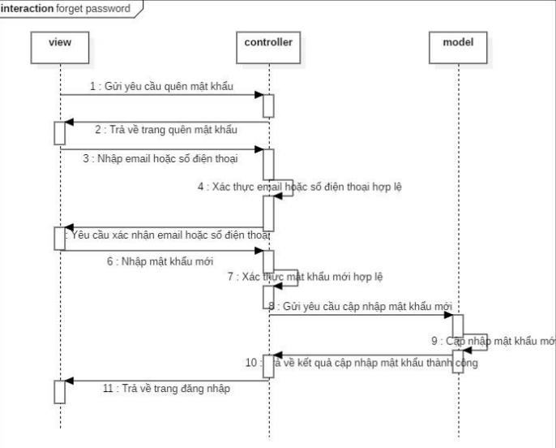

7, Use case Post hostel

|  |  |
| --- | --- |
| Objective | This use case allows users to post a new blog to rent users’ room or find roommates. |
| Actor | Hostels’ owner |
| Pre-condition | The actor must be registered on the platform and have the necessary details and photos of the hostel. |
| Main flow | 1: The owner/manager logs into their account.  2: They navigate to the ‘Post a Hostel’ section.  3: They enter details about the hostel, such as location, amenities, room types, and pricing.  4: They upload photos of the hostel.  5: They submit the hostel listing for review.  6: The system verifies the information and approves the listing.  7: The hostel is posted on the website and becomes visible to potential guests. |
| Post condition | The hostel is successfully listed on the website and can be searched and booked by users. |

* Activities flow:

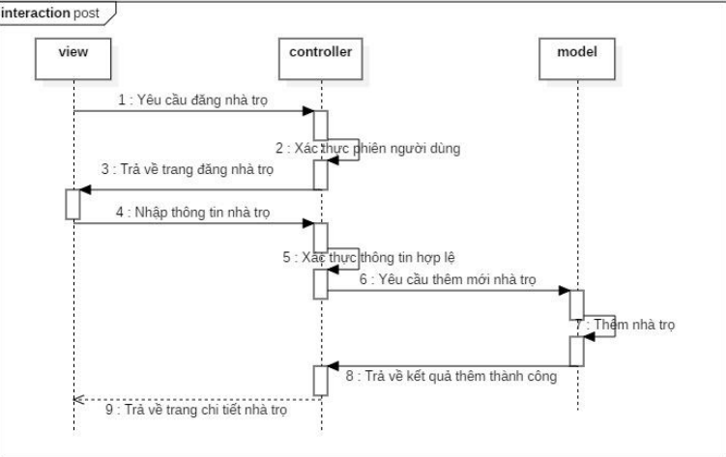

8, Use case view and update user information

|  |  |
| --- | --- |
| Objective | This use case allows users to update their information on the website. |
| Actor | Users want to change their information. |
| Pre-condition | The user must have internet access and be on the appropriate web page. |
| Main flow | 1: The user navigates to the section containing the information.  2: User changes personal information in these fields are able to change.  3: User clicks on Update.  4: The system validates the new information.  4.1: If new information are invalid, return to view information page.  4.2: If new information valid, the system will update new information to the user  5: The system notifies that the information has been updated successfully |
| Post condition | The user’s information is updated in the system, and they can continue to use the website with their new details. |

* Activities flow:

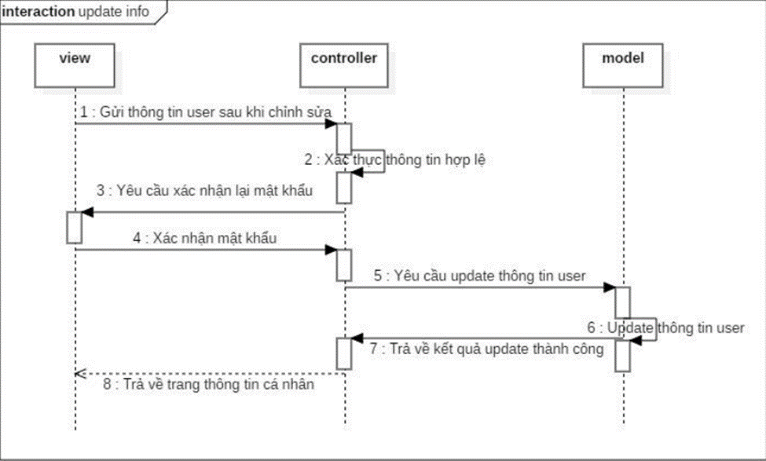

9, Use case change passwords

|  |  |
| --- | --- |
| Objective | This use case allows users change their password |
| Actor | Users |
| Pre-condition | The user must be logged in and have access to their account settings. |
| Main flow | 1: The user navigates to the account settings or security settings page.  2: The user selects the option to change the password.  3: The user enters their current password for verification. 4: The user enters the new password and confirms it by entering it again.  5: The system validates the new password and updates the account credentials.  6: The system confirms the successful password change to the user. |
| Post condition | The user’s password is updated, and they may be prompted to log in again with the new password. |

* Activities flow:

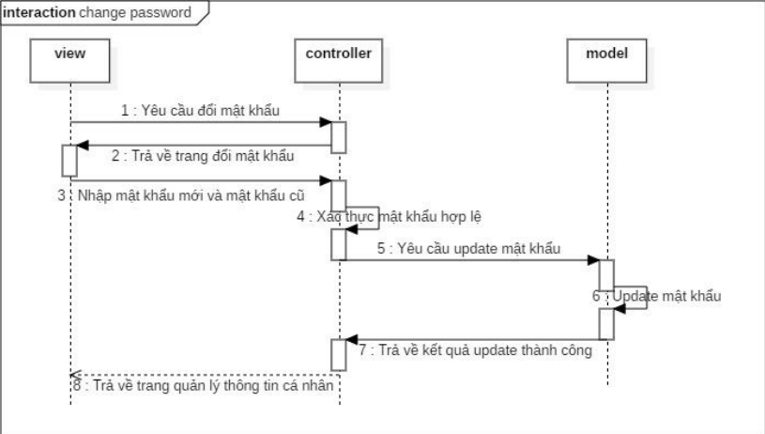

10, Use case Update hostel information

|  |  |
| --- | --- |
| Objective | This use case allows hostel owner or manager to update their property’s information on the website. |
| Actor | Hostel owners or managers. |
| Pre-condition | The actor must be registered on the platform and have the necessary permissions to update the hostel’s information. |
| Main flow | 1: The owner/manager logs into their account.  2: They navigate to the ‘My Hostels’ section.  3: They select the hostel whose information they wish to update.  4: They enter the updated information about the hostel, such as new amenities, updated pricing, or changes in availability.  5: They submit the updated information for review.  6: The system verifies the updated information and approves the changes.  7: The updated hostel information is posted on the website. |
| Post condition | The hostel’s information is updated on the website, and potential guests can view the latest details. |

* Activities flow:

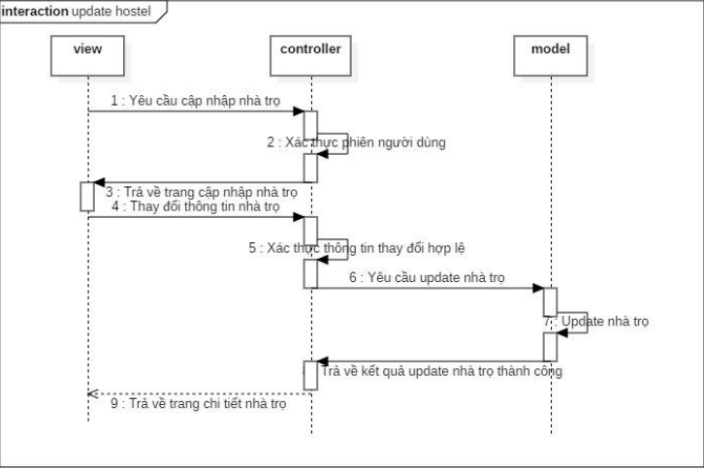

11, Use case Delete hostel

|  |  |
| --- | --- |
| Objective | This use case allows hostels’ users or admin delete or remove it from the website |
| Actor | Hostel owners or Admin. |
| Pre-condition | The actor must be registered on the platform and have the necessary permissions to delete the hostel’s information. |
| Main flow | 1: The owner/manager logs into their account  2: They navigate to the ‘My Hostels’ section.  3: They select the hostel listing they wish to delete.  4: They initiate the deletion process.  5: The system asks for confirmation to prevent accidental deletions.  6: Upon confirmation, the system removes the hostel listing from the website. |
| Post condition | The hostel listing is no longer available on the website, and users cannot search for or book it. |

* Activities flow:

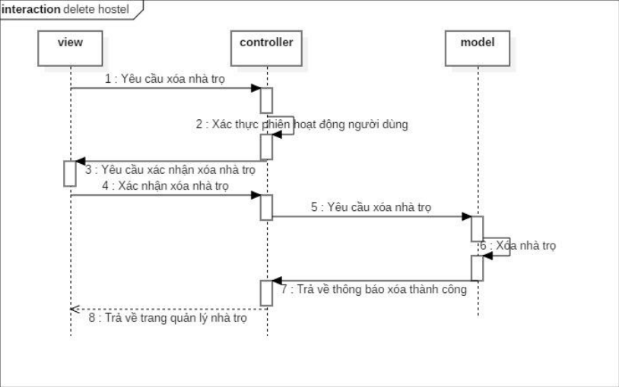

12, Use case Logout

|  |  |
| --- | --- |
| Objective | This use case allows users or admins logout the website |
| Actor | Users, Admin |
| Pre-condition | The user must be logged in to the website. |
| Main flow | 1: The user clicks on the ‘Logout’ button or link.  2: The system ends the user’s session.  3: The user is redirected to the login page or the homepage of the website. |
| Post condition | The user is logged out and must log in again to access restricted areas of the website. |

Activities flow:

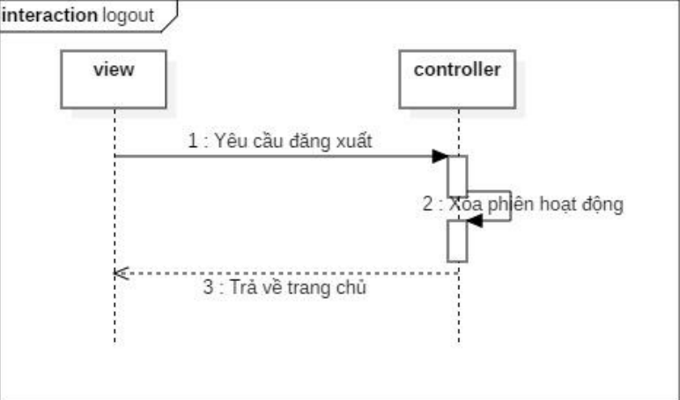

13, Use case Delete user

|  |  |
| --- | --- |
| Objective | This use case allows an administrator or authorized user to remove a user account from the system. |
| Actor | Admin. |
| Pre-condition | The actor must be logged in with sufficient permissions to delete user accounts. |
| Main flow | 1: The administrator navigates to the user management section.  2: They search for the user account they wish to delete.  3: They select the user account.  4: They initiate the deletion process.  5: The system asks for confirmation to prevent accidental deletions.  6: Upon confirmation, the system removes the hostel listing from the website.  7: Both the user account and hostel of the user are removed from the system. |
| Post condition | The user account is no longer present in the system, and the user cannot log in or access the system |

14, Use case Static.

|  |  |
| --- | --- |
| Objective | This use case allows an administrator analysis the system’s work |
| Actor | Admin. |
| Pre-condition | Admin must be logged in. |
| Main flow | 1: Admin clicks on “Analyze/Evaluate”.  2: The system redirects to the analysis page to evaluate the website's performance.  3: The system will display assessment charts about the website's performance.  3.1: Review analysis on Number of new users.  3.2: Analysis of reviews on Number of motels.  3.3: Analyzing and evaluating the distribution of boarding houses by area. |
| Post condition | The user is able to view the report and analyze the data for decision-making purposes. |

15. Use case payment via Momo.

|  |  |
| --- | --- |
| Objective | This use case allows users to add money to their account to perform the post function |
| Actor | User |
| Pre-condition | User must be logged in.  User must have a valid payment method linked. |
| Main flow | 1. User selects the option to pay via Momo.  2: System redirects the user to the Momo payment gateway.  3: User confirms the payment amount and authorizes the transaction.  4: Momo processes the payment and deducts the specified amount from the user's Momo account  5: Momo sends a payment confirmation or failure notification to the system.  5.1: If payment is successful, the system updates the user's account balance.  5.2: If the payment fails, Momo notifies the user and redirects back to the system without updating the balance. |
| Post condition | User's account balance is increased by the amount added via Momo.  User can now use the balance to perform the post function |

**CHAPTER 4: RESULT**

**4.1 Result in guests.**

4.1.1 Main page.

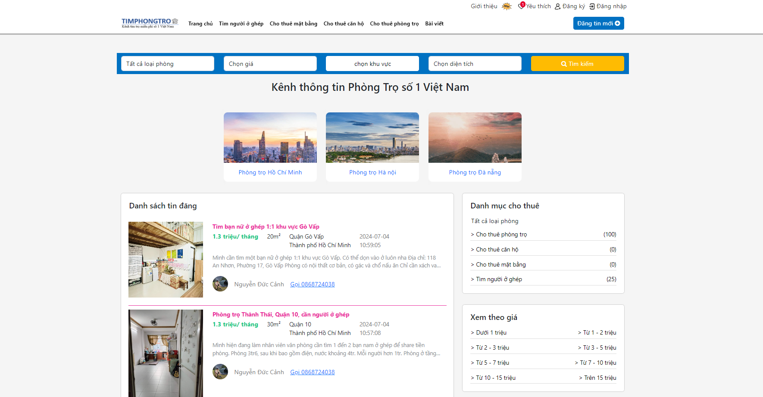

4.1.2 Search hostel.

Customers can choose several criteria in the search bar to filter the hostel or click on each category in the right of the system.

- First: category:

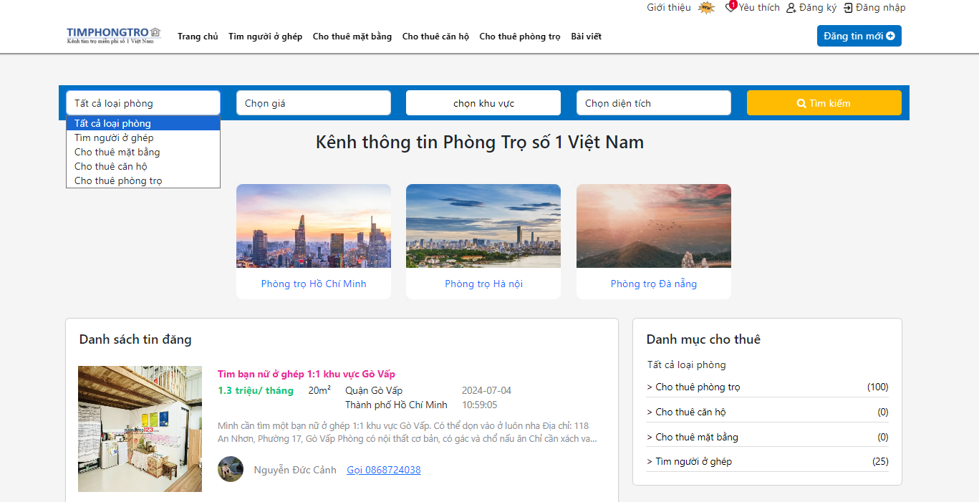

- Second: Price

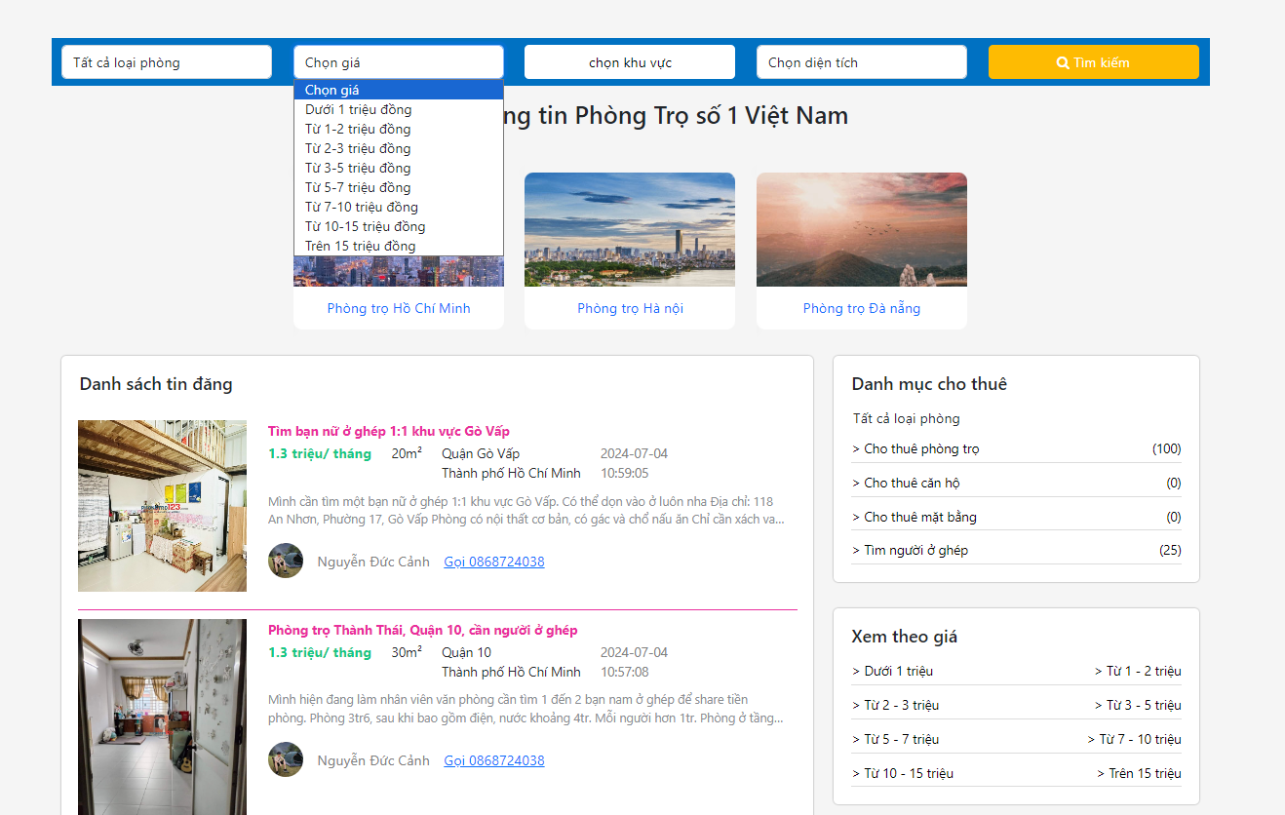

- Third: Location. In the search bar, customers can choose location to commune level

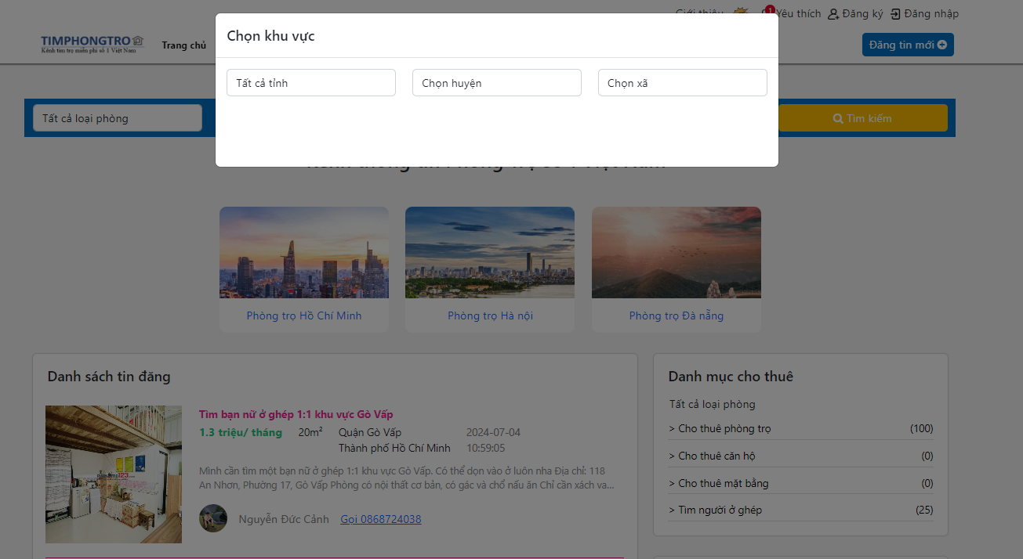

-Fourth: Search by area.

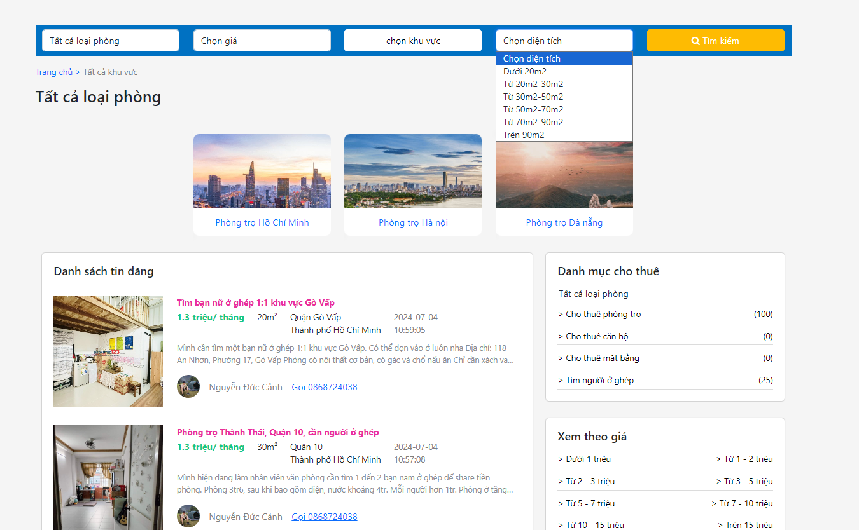

4.1.3 See detail hostel

When users click on any post, the system will direct users to the page illustrating details of this hostel.

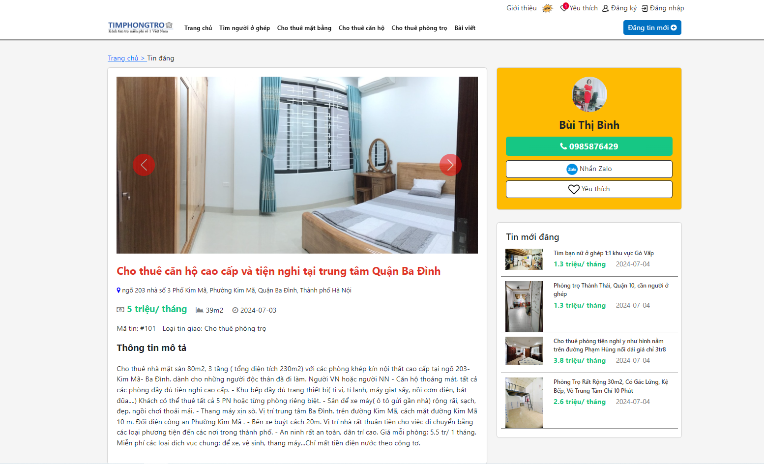

Here is the information about a hostel. Beside details hostel, customers can see the information of owner hostel to contact.

**4.2 Result in users.**

When customers want to post room or want find roommates. They must login/register.

4.2.1 Login page.

When customers click on login in the right top conner, the system will direct them to the login page.

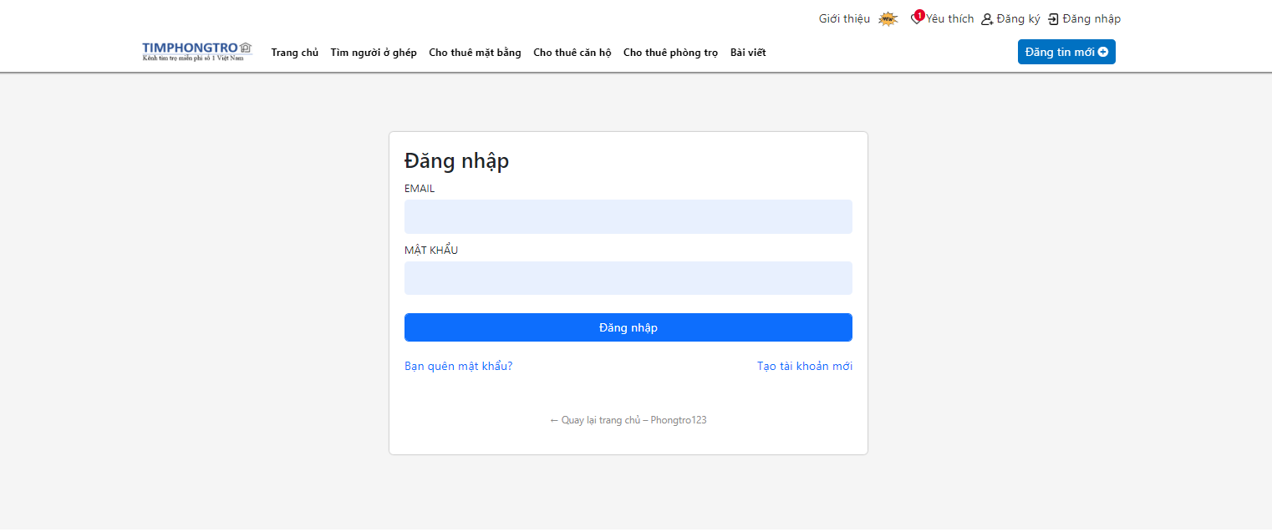

4.2.2 Registration page.

When customers want to login, but they do not have an account, they can click to register in the login page or in main page.

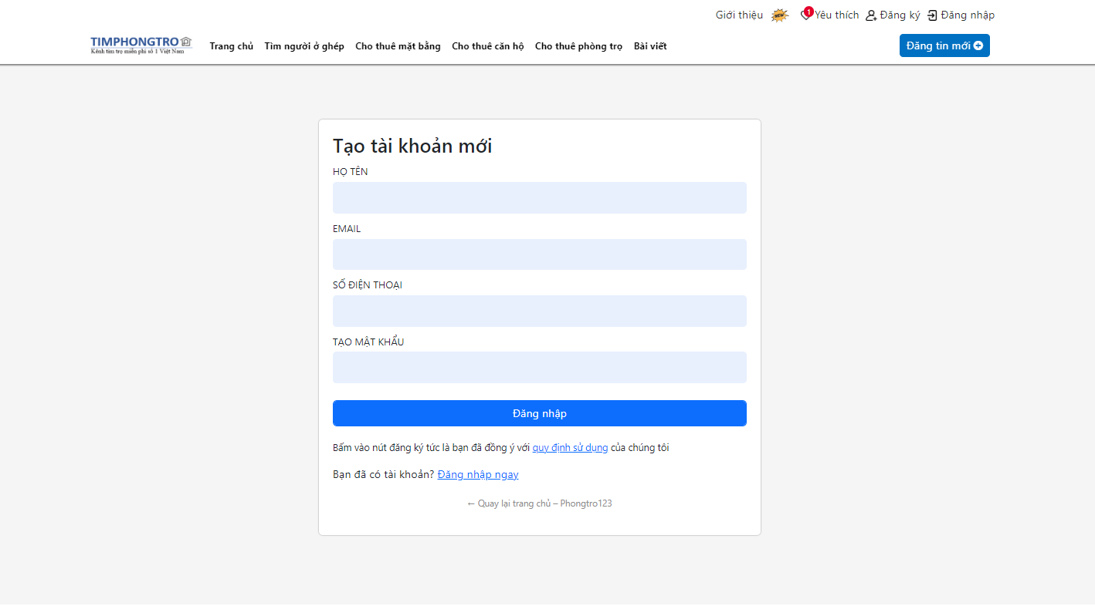

4.2.3 Email confirmation.

After registering successfully, the system will notice for the user to check email to confirm.

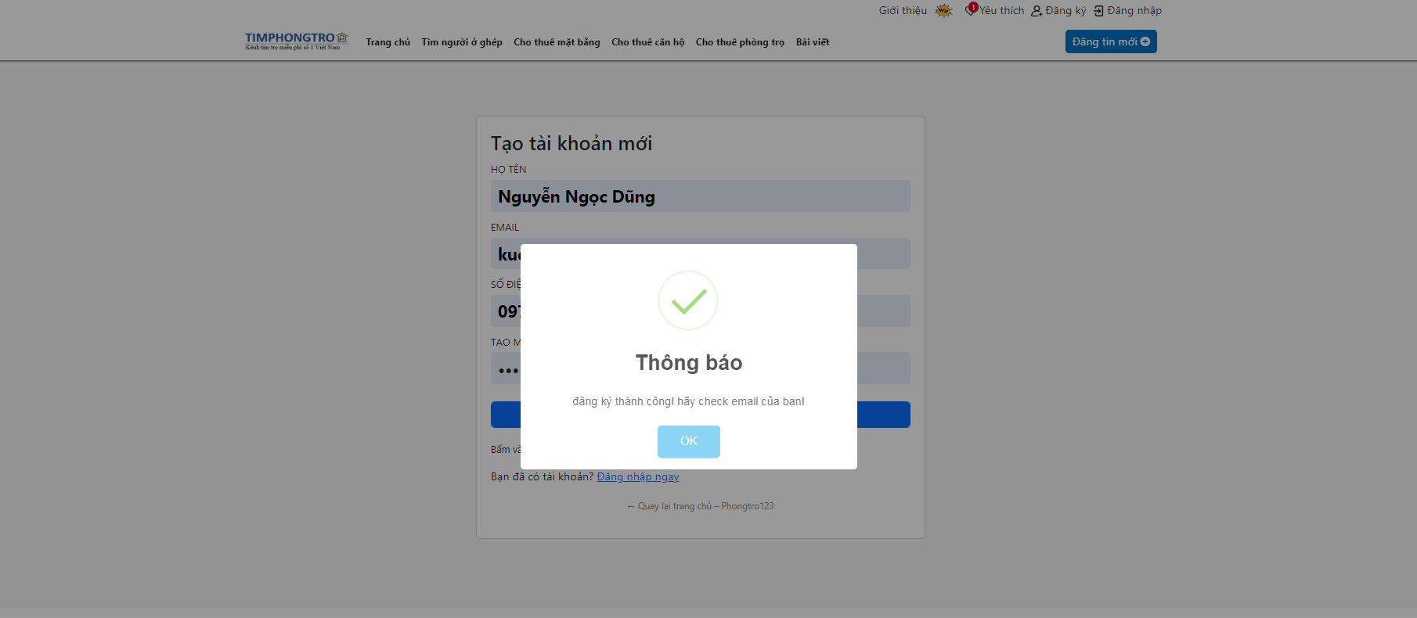

Email confirmation:

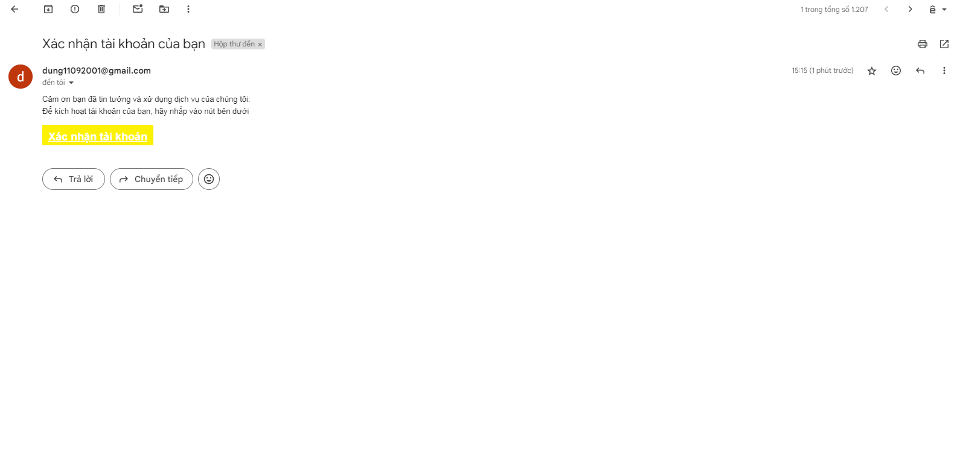

When user clicks on confirmation account, the system will active user’ account and user can login with this account to this website.

4.2.3 Forgot password.

If users forget password, they can click on forget password.

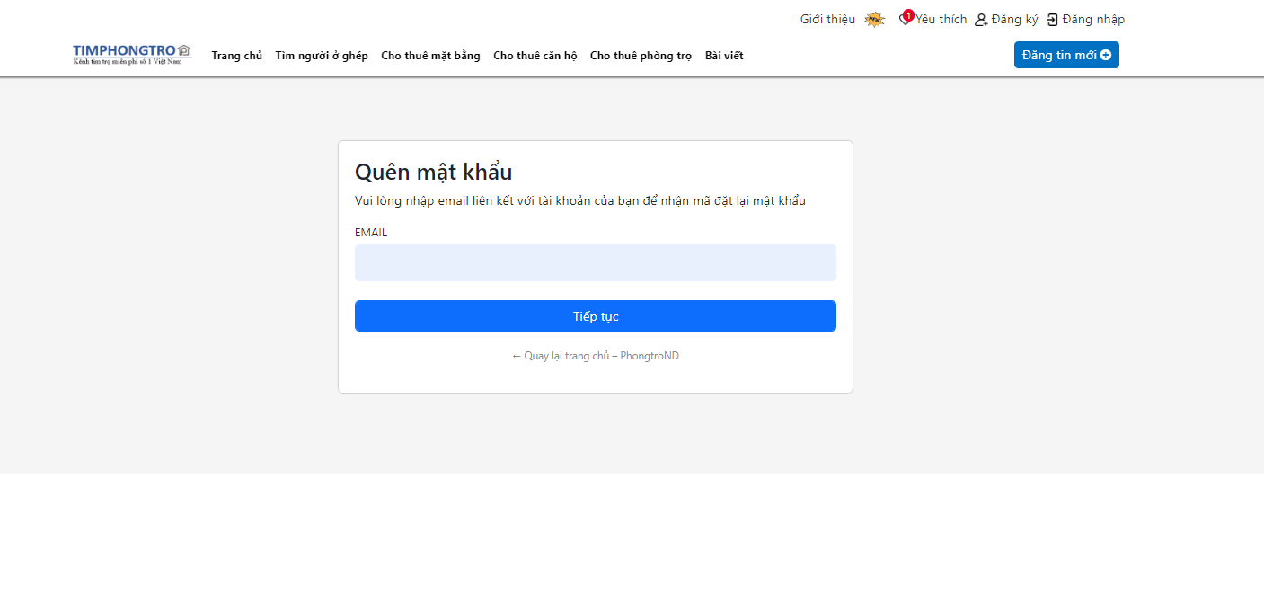

After users enter email address. They click on Continue to receive new password in their email.

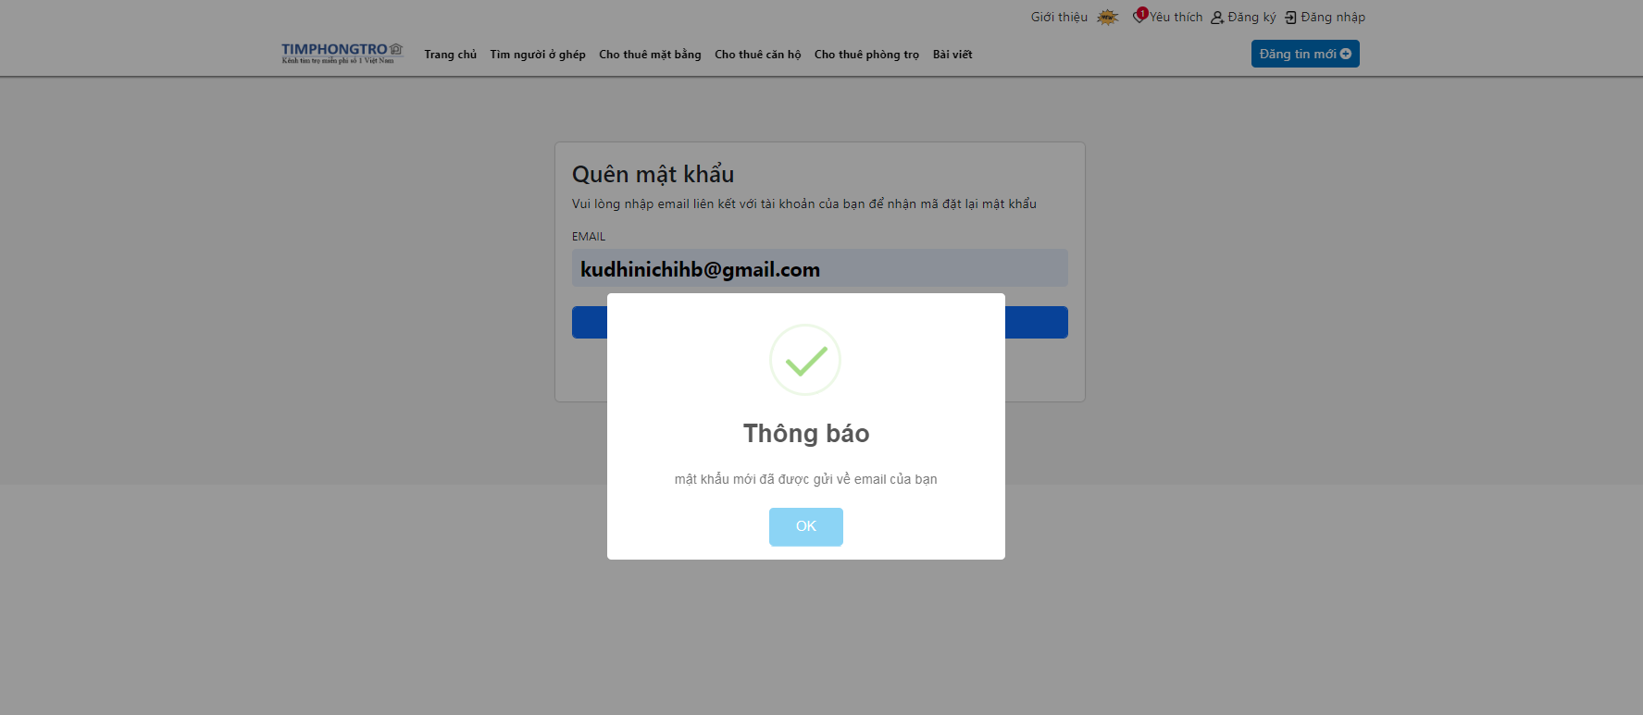

Email template to receive new password.

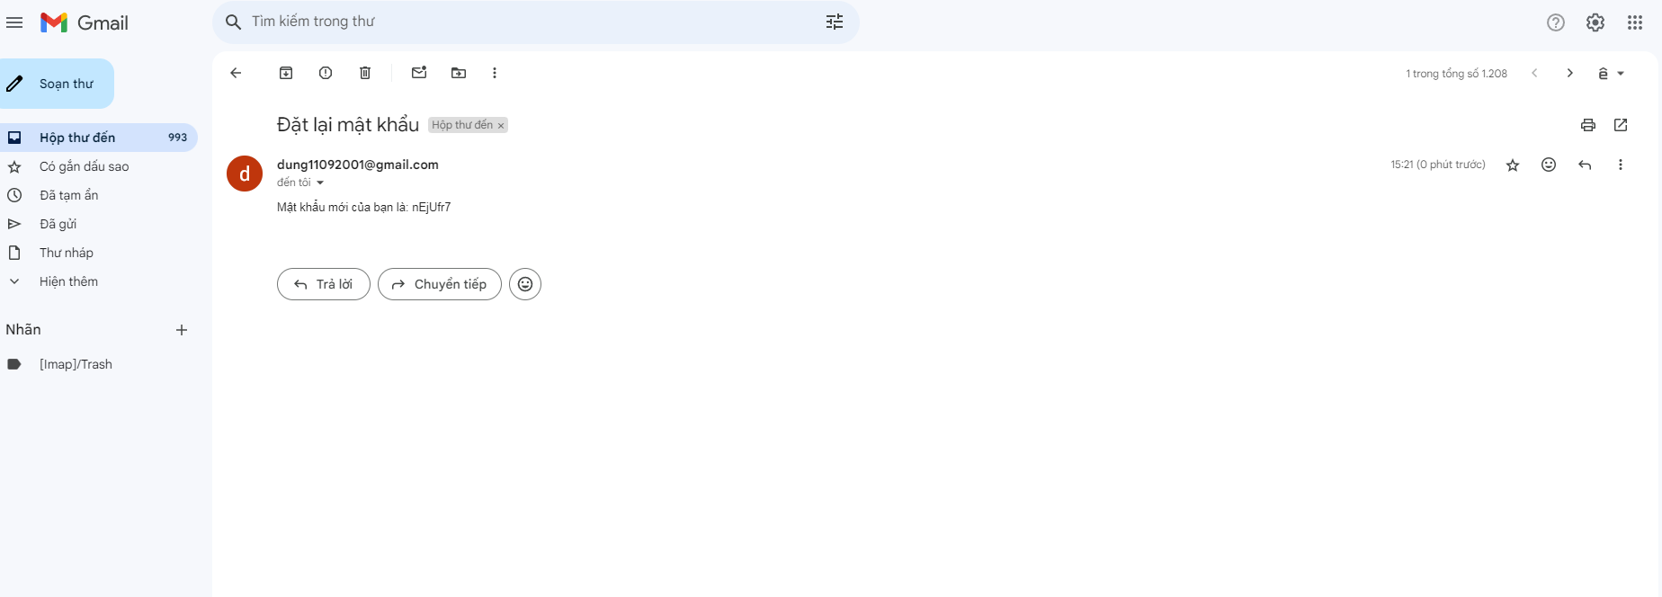

4.2.3 Post hostel page.

After login, if users want to post their hostel, they click on “Post new hostel” in main page.

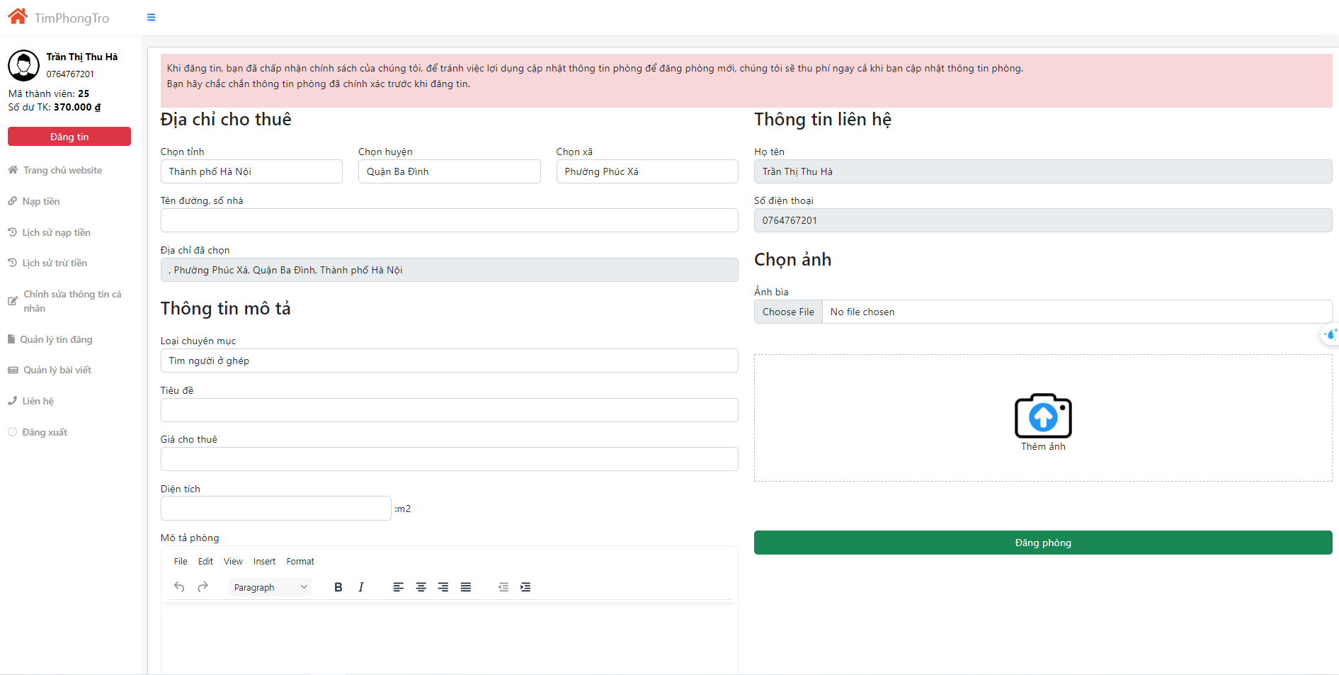

Users must fill all the information like location, category, title … to post a hostel. If the information is valid, the system will notice “user posts hostel successfully”.

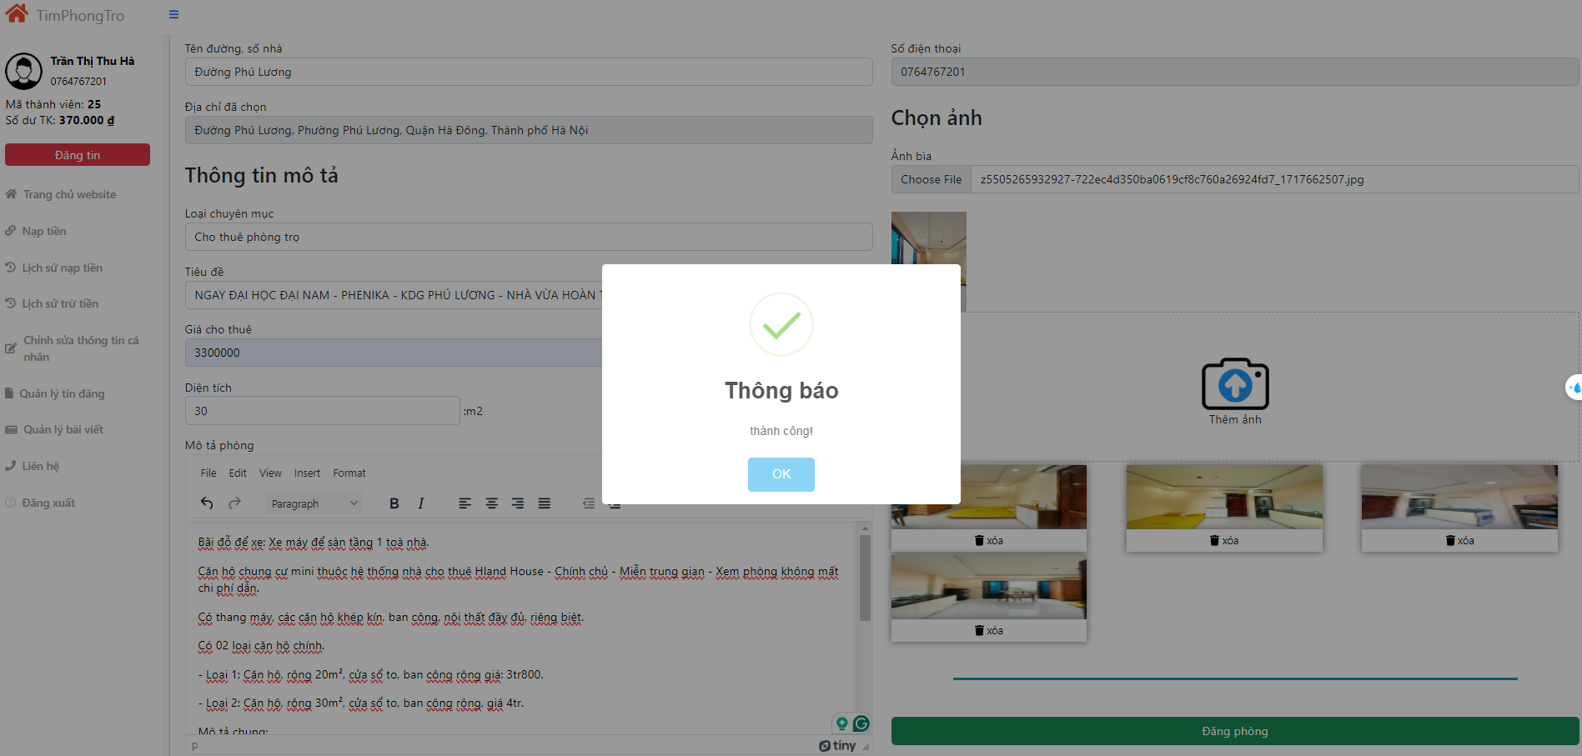

4.2.4 Manage posted hostel page.

When users post a new hostel successfully, the system will direct to manage hostel page.

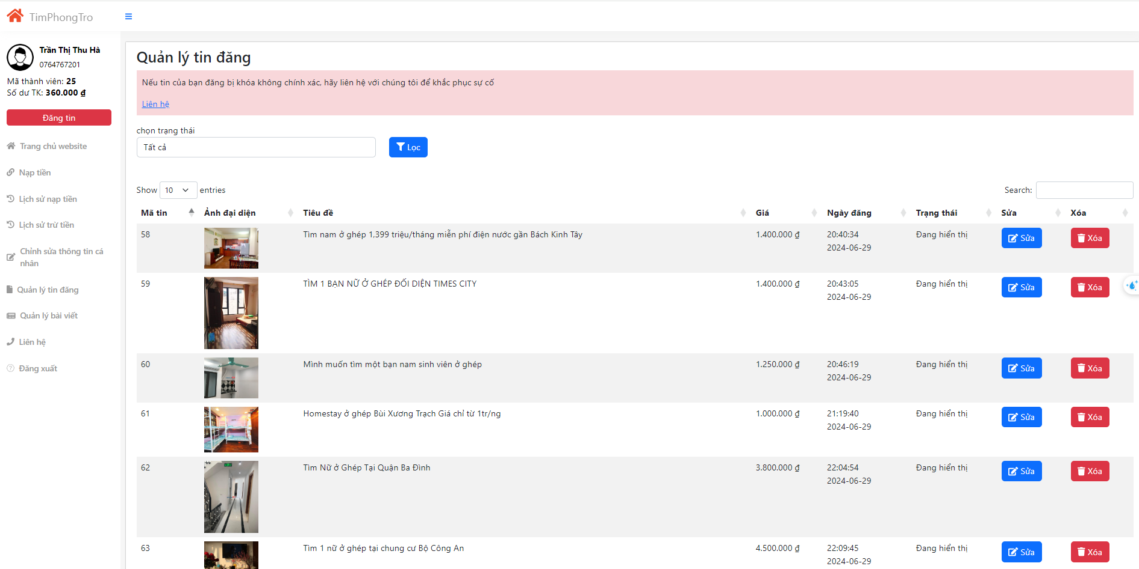

In this page, users can see all the hostel they post, they can edit or delete these room.

4.2.5 Update hostel page.

When landlord miss or fill wrong information of this hostel, they click on edit button to fix this wrong information. The system will direct to post hostel page.

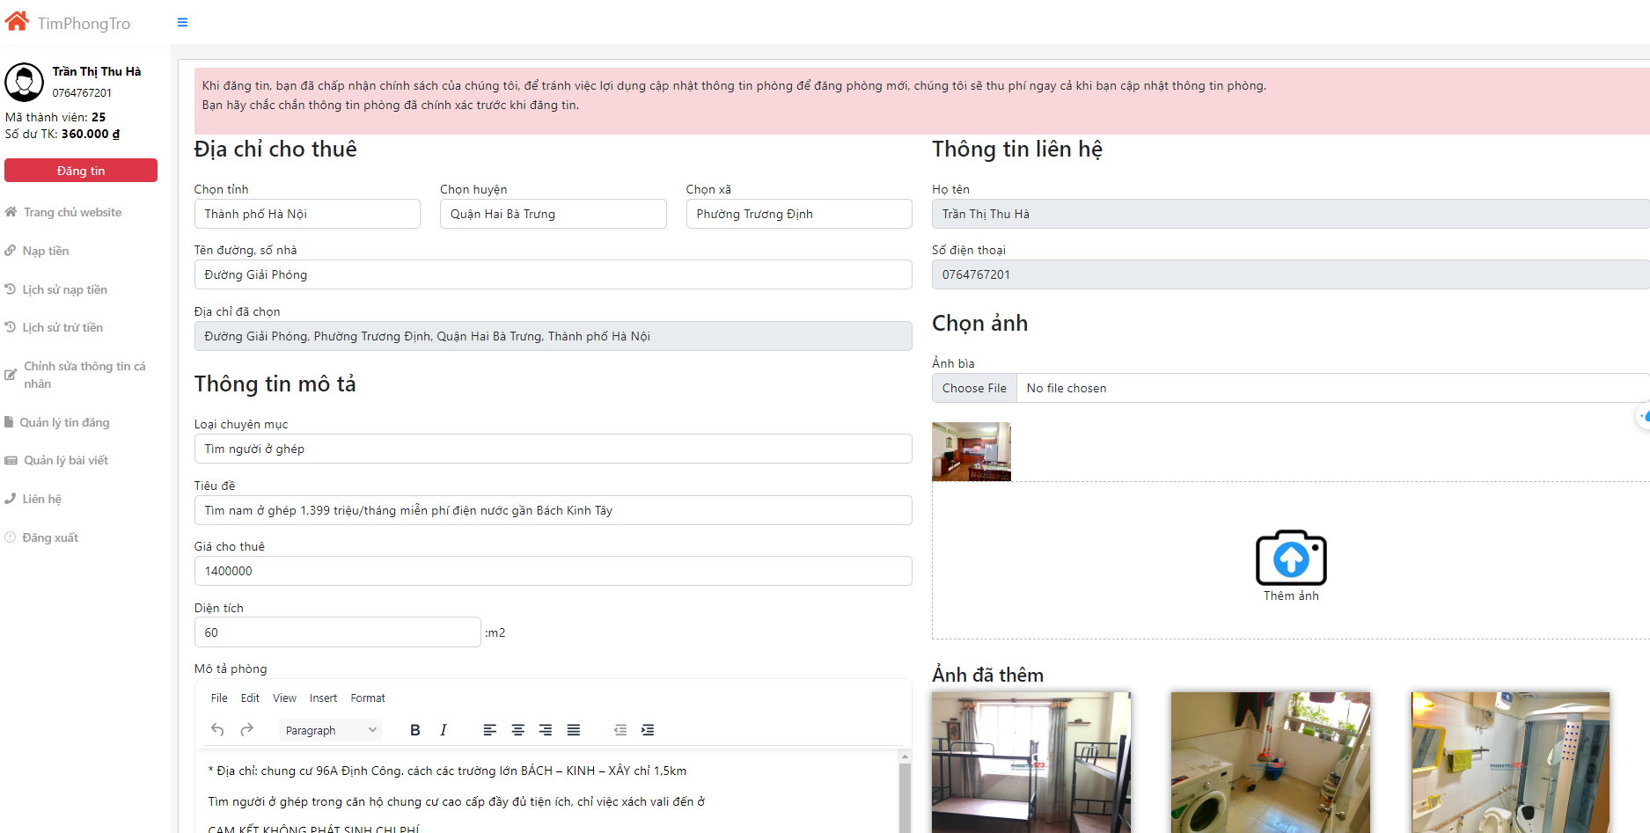

4.2.6 Delete hostel page.

When users click button delete in particular room, the system will delete it and notice for owner.

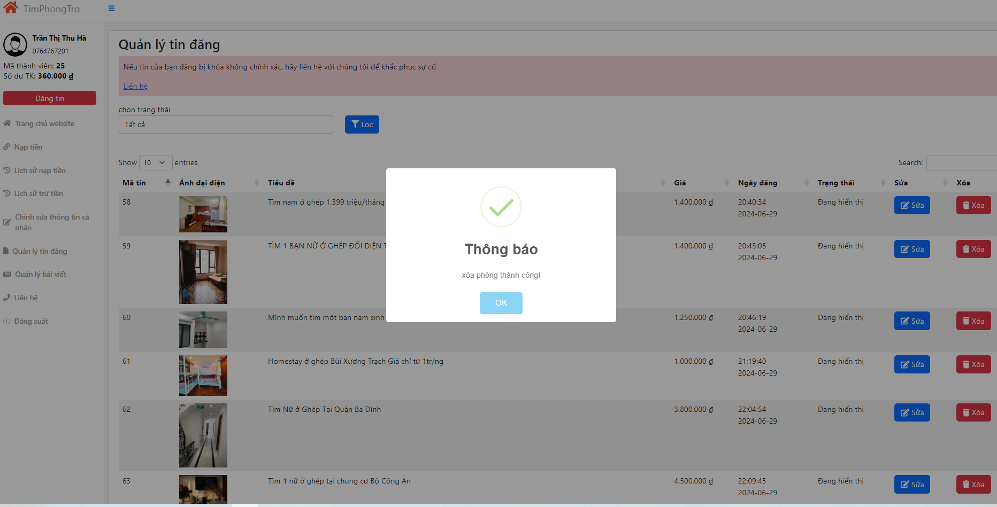

4.2.5 User information page.

Users can check their information on the user information page. They can change name, phone or update avatar, link Facebook.

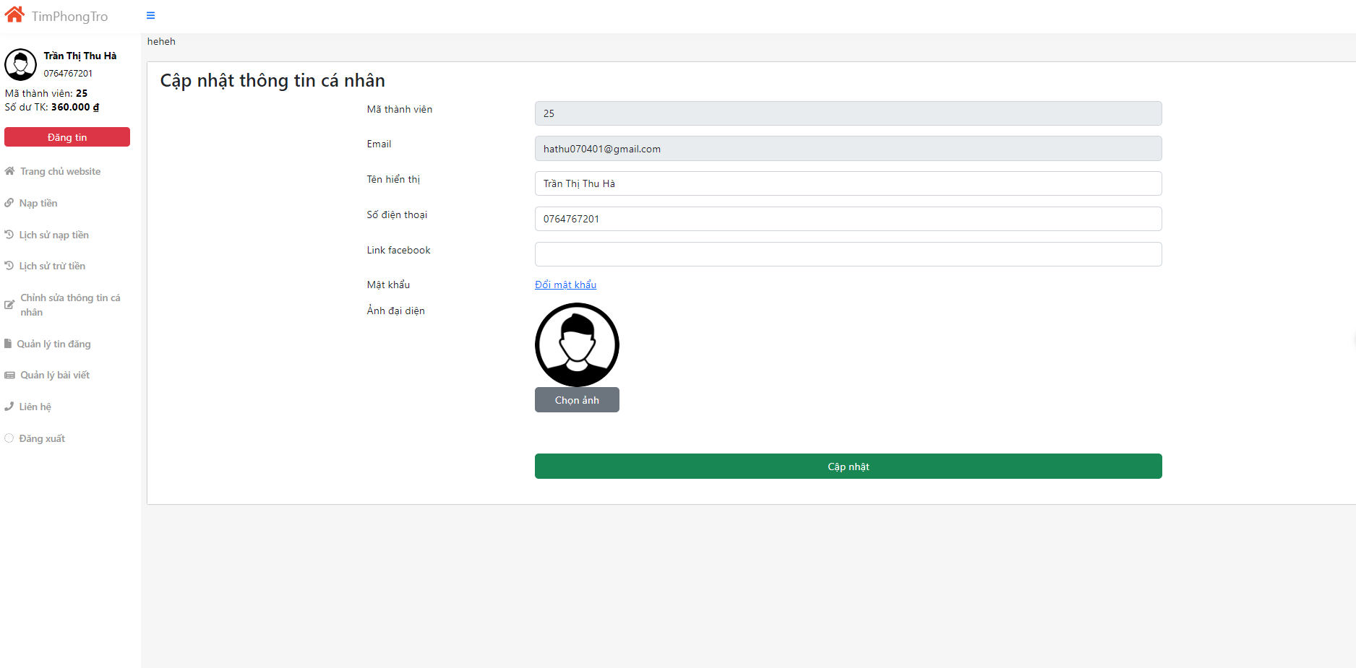

4.2.6 Changing password

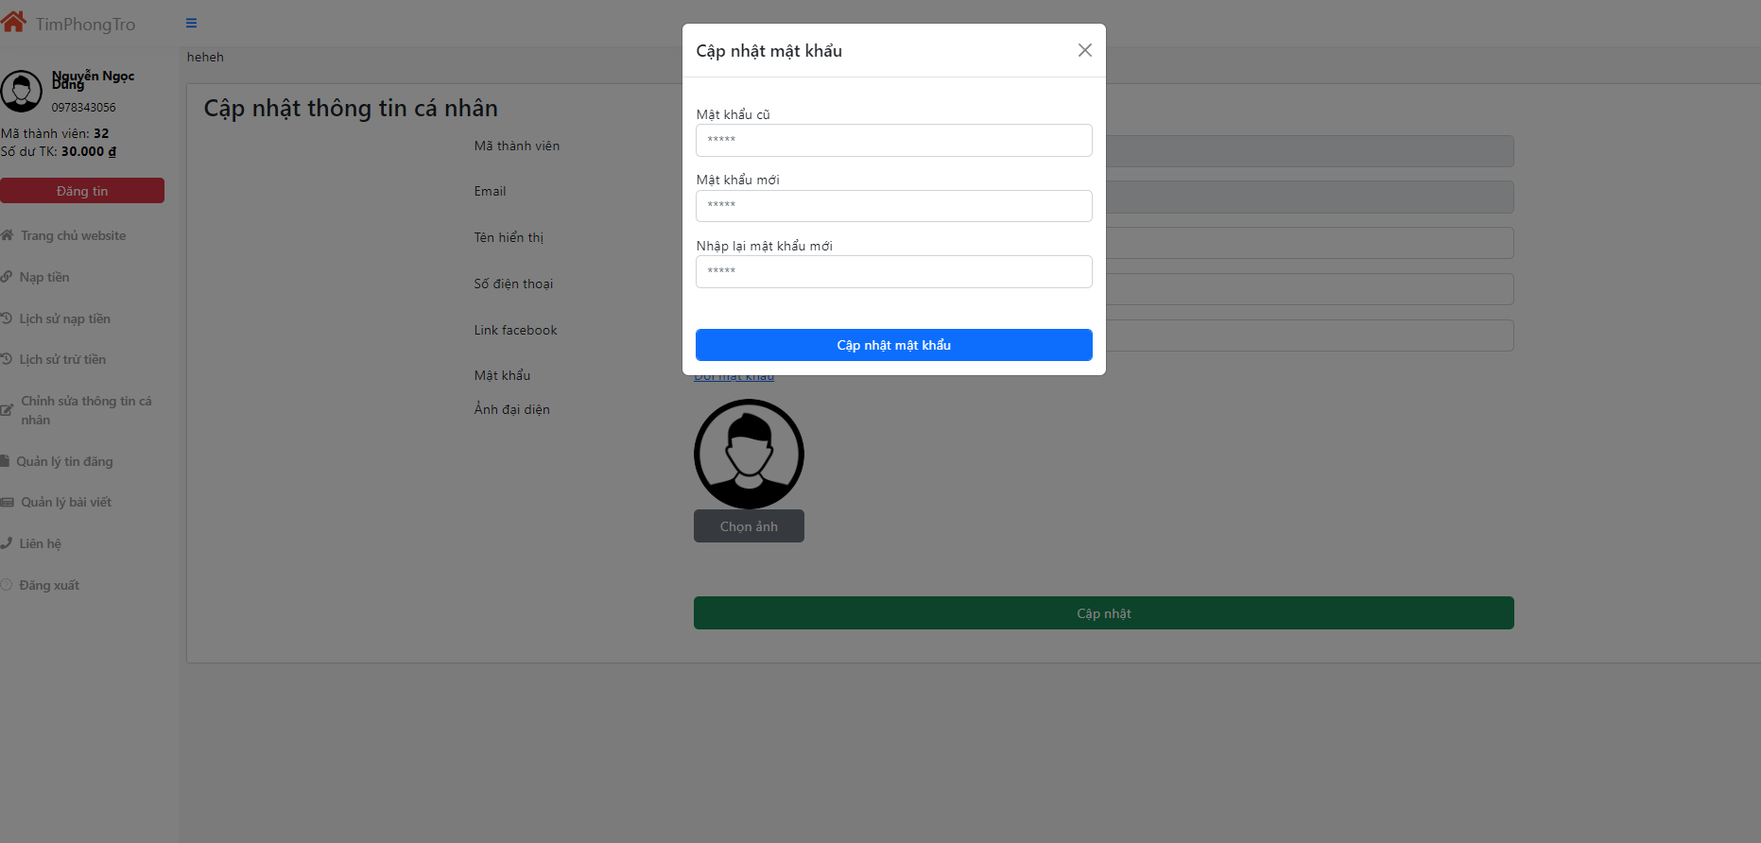

User must fill correctly old password and confirm new password must be same with new password.

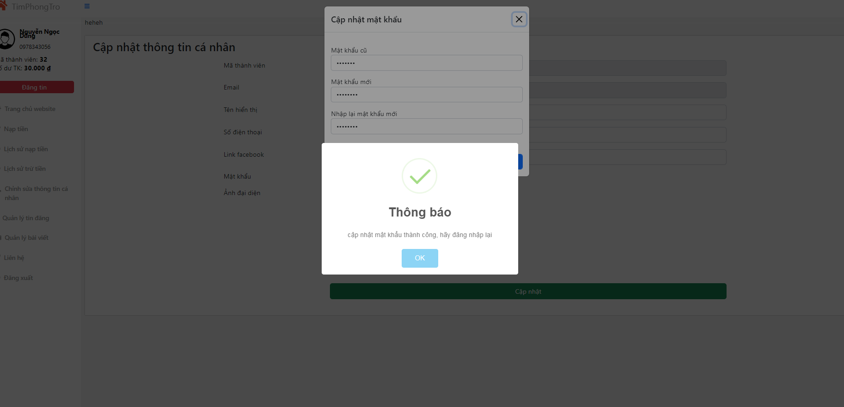

4.2.7 Payment page.

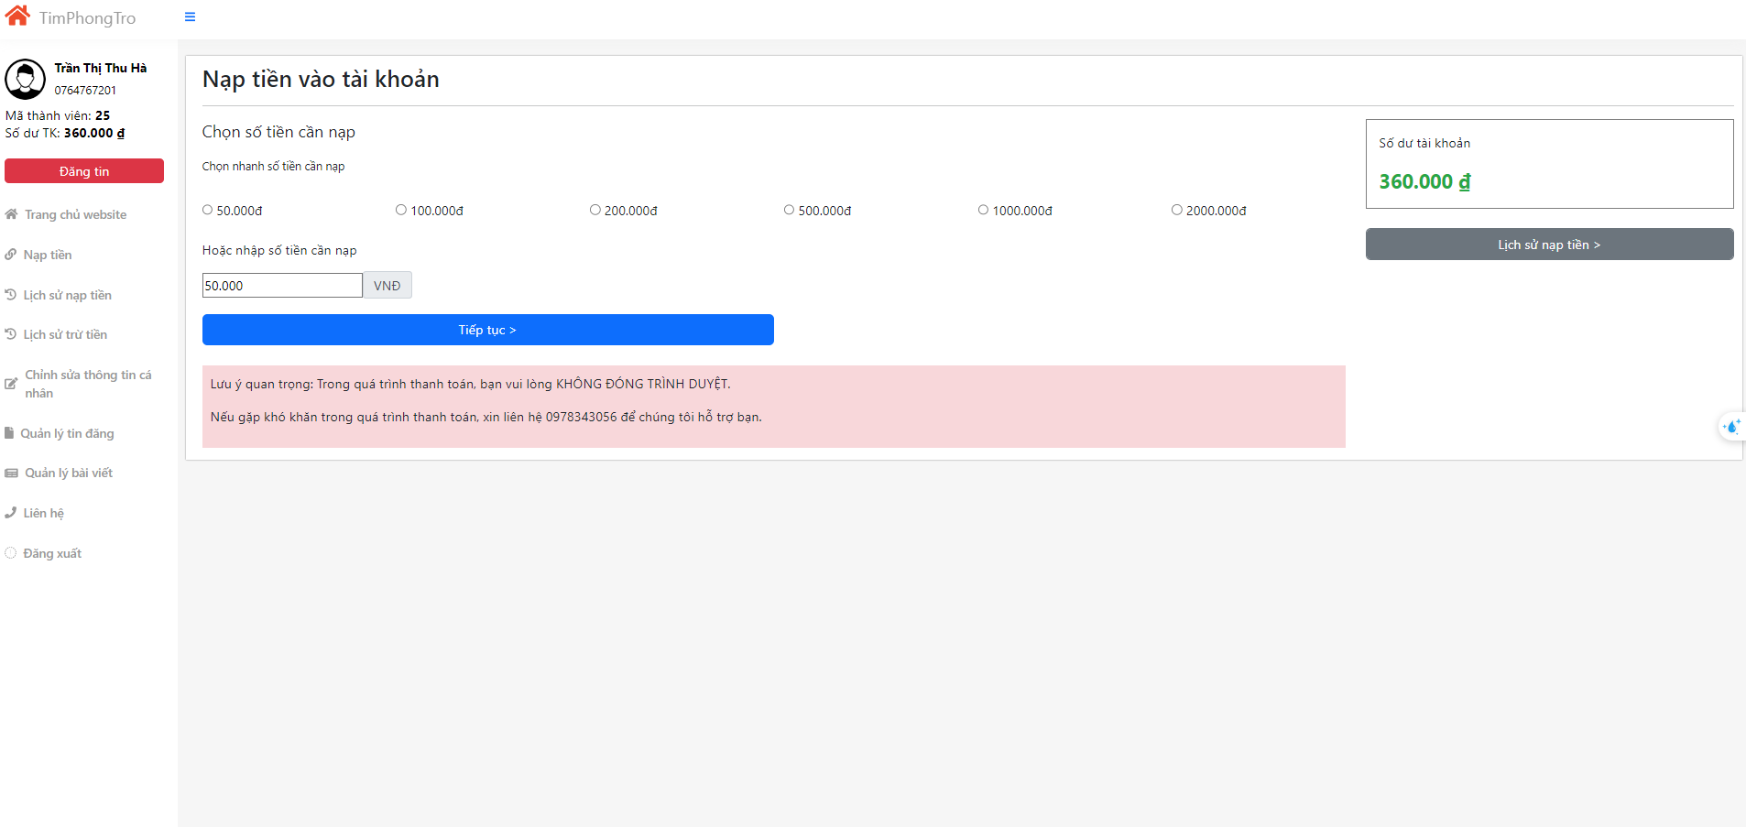

Users can choose the amount they want to add to their account. After choosing the amount they click on continue, the system will direct them to Momo payment.

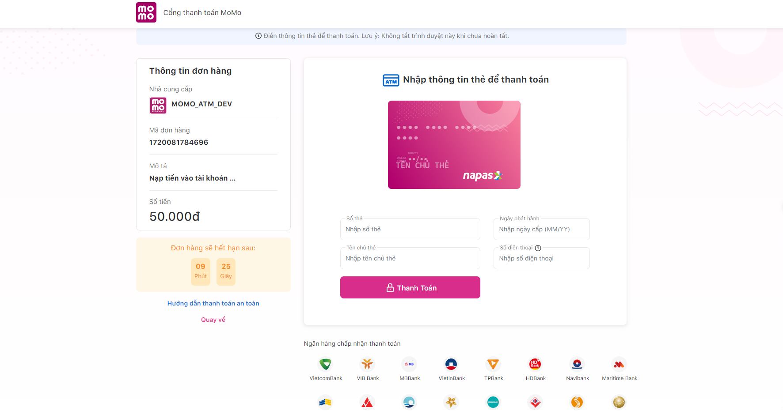

To make a transaction, users must fill their cash information to payment. After filling information, users click on Payment, their must fill OTP code to implement this transaction.

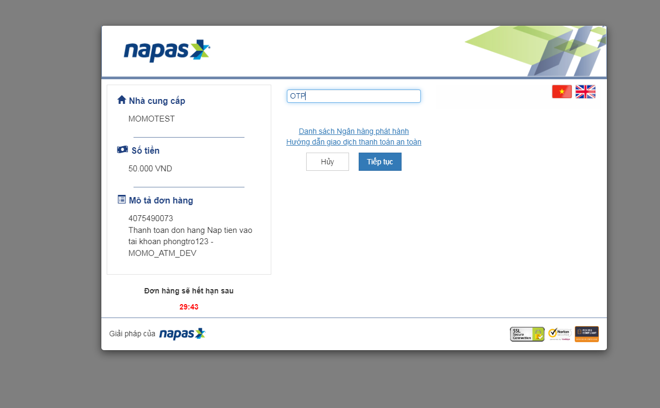

Users must fill OTP code and click continue. The system of Momo will check and if information is valid, Momo notices that payment successfully and returns to history payment page.

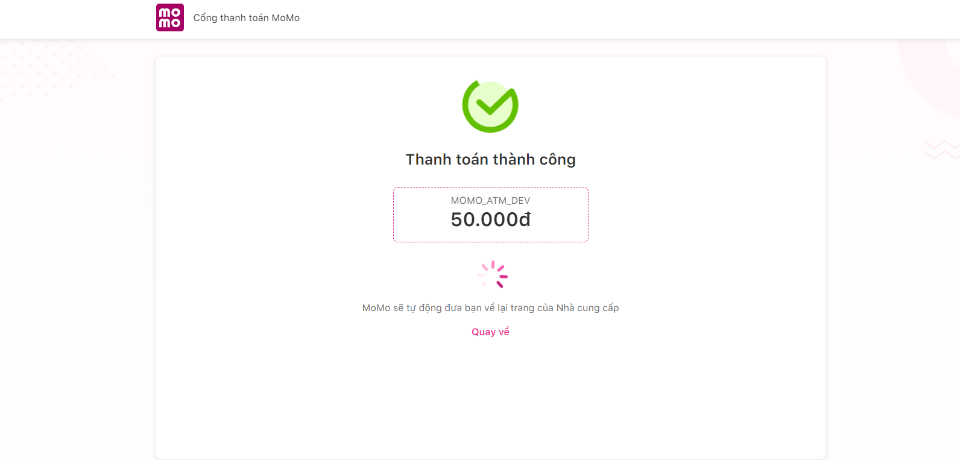

4.2.8 Top up history page.

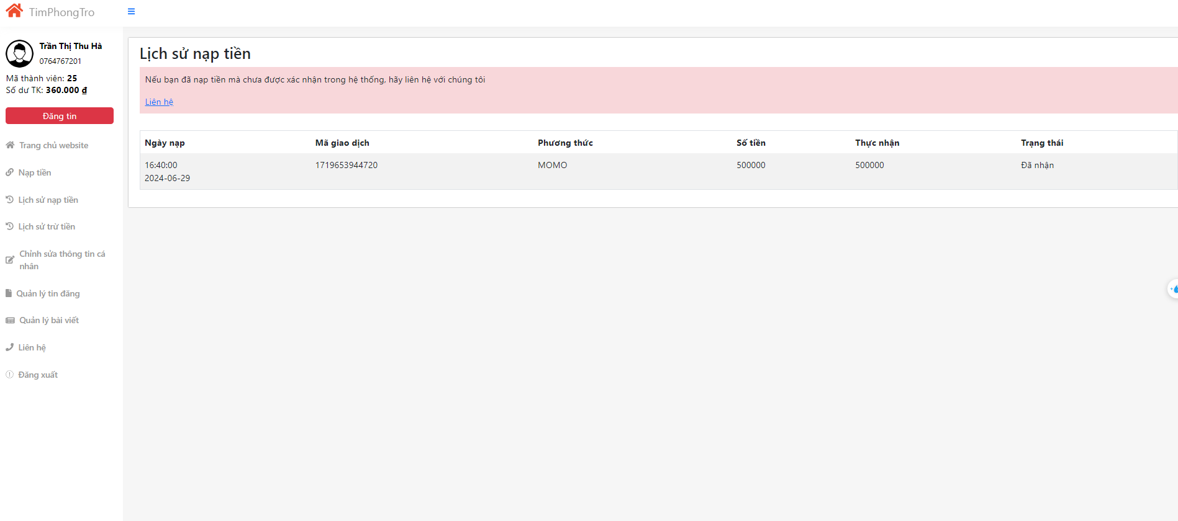

4.2.9 Deduction history page.

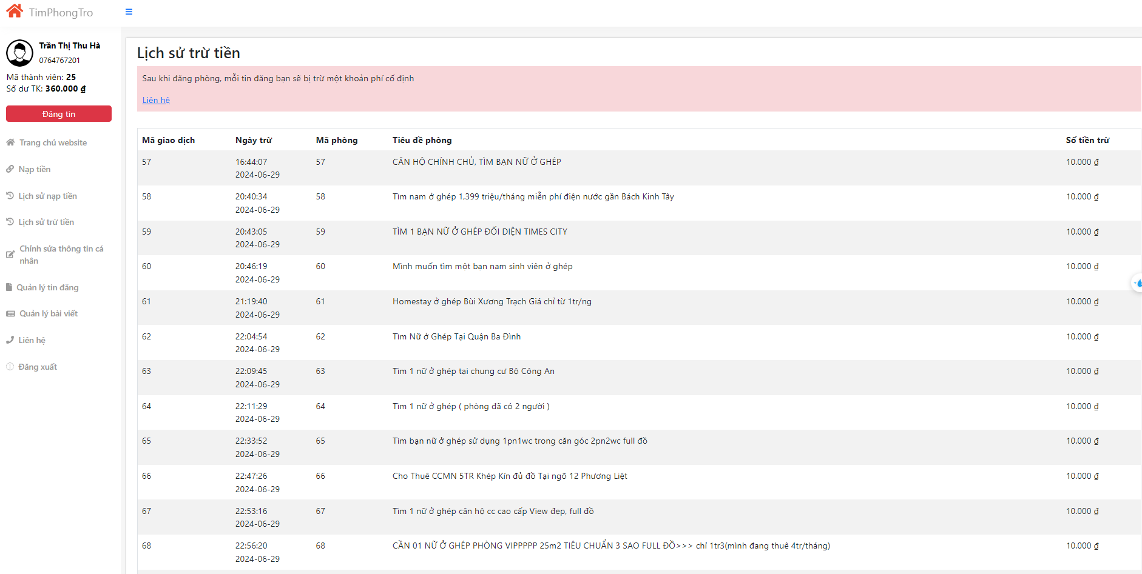

**4.3 Result in administration.**

4.3.1 Overall page.

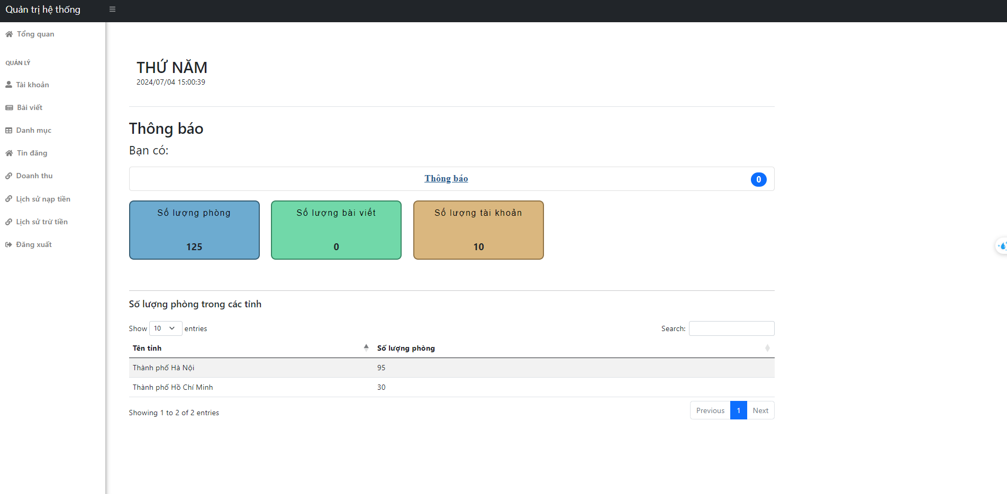

In overall page, admin can follow the number of rooms, accounts and the number of rooms in every province.

4.3.2 Manage account page.

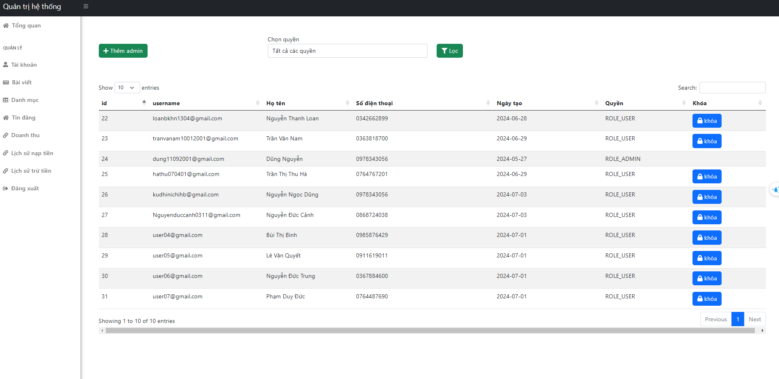

They can check information of all accounts and if one user does not follow the rule, the user will be locked by admin.

4.3.3 Manage blog page.

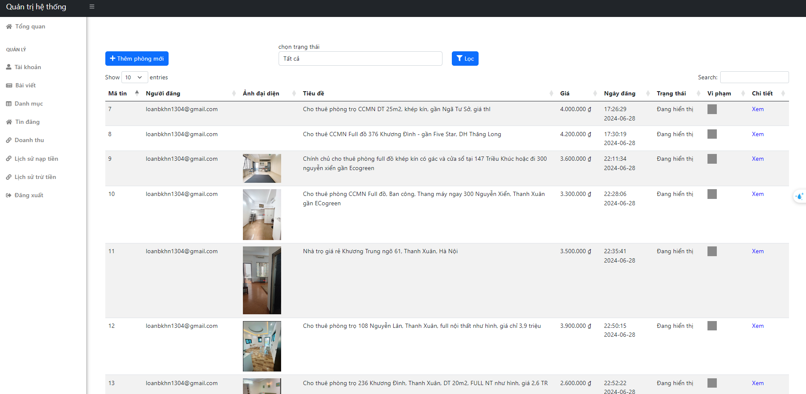

4.3.4 Manage category page.

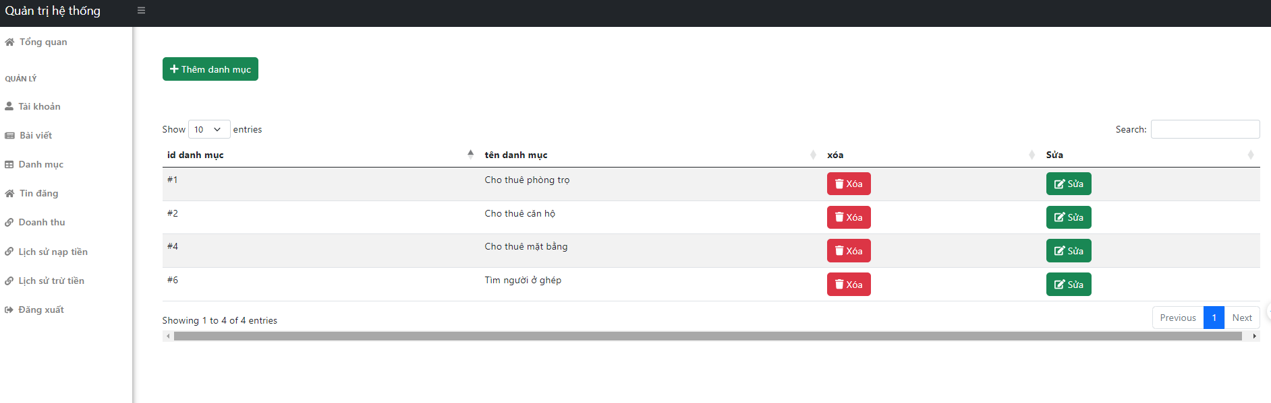

4.3.4 Revenue page.

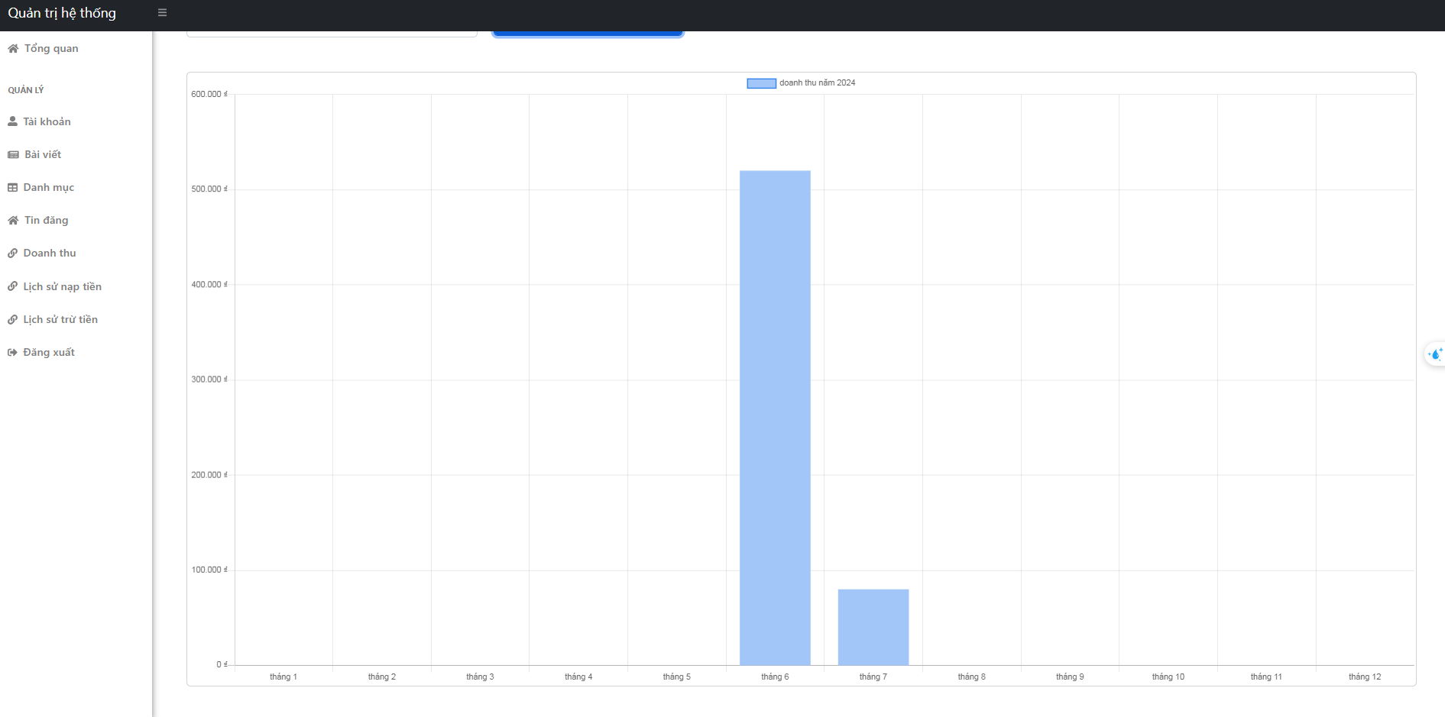

4.3.5 History payment of user’s page.

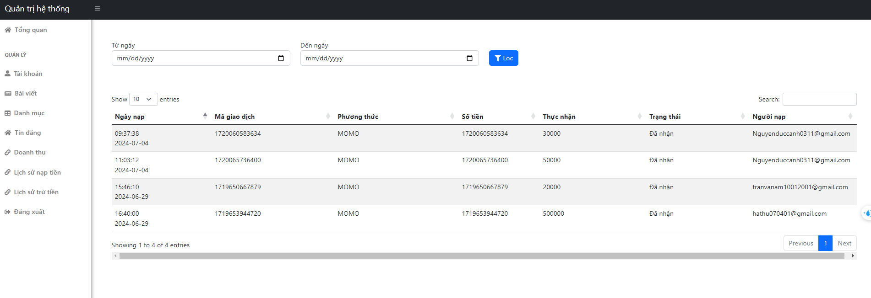

4.2.6 Deduction history payment page.

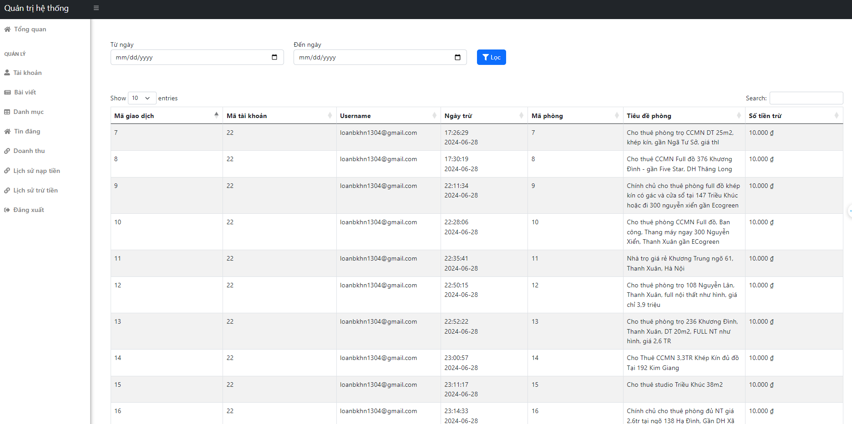

Figure 1

**CHAPTER 5: CONCLUSION**

5.1 Conclusion

After researching and analyzing, I have developed a website system to support finding rental houses for my graduation project. Using the programming skills and knowledge I have acquired, such as JavaScript, HTML, CSS, Java Spring Boot, and MySQL database, I have created a complete system.

This system can bring many benefits to users, allowing people to easily search for rental information and post listings effortlessly. In particular, the website features a dedicated management page for landlords, helping them manage their listings easily.

Applying modern programming skills and technologies like Java Spring Boot and MySQL has helped me create a reliable and efficient system. I utilized the data processing and logic capabilities of the Spring framework to build APIs that support searching for rental information and revenue statistics. Additionally, by using MySQL, I stored and queried data effectively to ensure the system runs smoothly and reliably.

Moreover, working on this project has helped me apply and hone my programming, project management, and testing skills. I learned how to build a complex project from start to finish, from requirement analysis, system design, implementation, to testing. This experience has enhanced my ability to work independently, manage time, and solve issues that arise during development.

However, like any development project, my system still has some shortcomings and room for improvement. In the future, I will continue to upgrade and develop the system to better meet user requirements. I will keep learning and applying new and advanced techniques to improve the system's performance and features. I aim to optimize the code and improve the user interface to provide the best user experience.

I am confident that the knowledge and skills I have gained from this project will continue to contribute to my growth in the software development field.

5.2 Future development

Due to my limited capabilities and the short time frame for implementation, the project has not fully met all the functionalities that a rental search website requires. Therefore, to make the project more comprehensive, practical, and highly applicable, it needs to be supplemented with additional features.

I propose developing the following additional features:

* Integration with Facebook and Google accounts
* Adding a chat function between landlords and tenants
* Adding a feature to search for rooms in nearby locations using Google Maps

**REFERENCES**

[1] Oliver Gierke, Thomas Darimont, Christoph Strobl, Mark Paluch. 2017. Spring Data JPA - Reference Documentation.

[2] Donald Bell. 2010. UML basics. Part II: The activity diagram. The activity diagram's purpose. by Donald Bell IBM Global Services

[3] <https://developers.momo.vn/v3/vi/docs/payment/api/wallet/onetime>

[4] <https://stackoverflow.com/>

[5] [Mô hình MVC trong JAVA web JSP/Servlet là gì? – itphutran.com](https://itphutran.com/mo-hinh-mvc-trong-java-web-jspservlet-la-gi/)